Brief History and Rules of Zoological Nomenclature:

The below mentioned article provides an overview on International Code of Zoological Nomenclature:-
1. Brief History of International Code of Zoological Nomenclature
2. Parts of International Code of Zoological Nomenclature
3. Rules.

Brief History of International Code of Zoological Nomenclature:
The need for a code to give a scientific name to every species was first realised by British Association for the Advancement of Science in 1842, when a set of rules were framed by it. This was also felt by American Association for the Advancement of Science in 1877. Then similar learned bodies in different countries like France, Germany and Soviet Union developed codes for their respective countries.
In 1889, at the International Congress of Zoology in Paris, discussions were made to find out some common code of nomenclature. First version of the code .was adopted in the Vth International Congress of Zoology in Berlin in 1901. In the XVth session held in London in 1958, the codes were rewritten and published on 6th November, 1961 and the updated version of the code (1961) was made available in 1964 (2nd edition).
This code is concerned only up to naming of superfamily and did not satisfy the zoologists. The latest edition (4th edition) of the code was published in 1999 and its effective use has started from 2000.
The International Zoological Congress elects a judicial body, called International Commission of Zoological Nomenclature which interprets or recommends the provisions of the code for classification or nomenclatural problems of the animals.
Again the International Code of Zoological Nomenclature (ICZN) formed by the International Commission of Zoological Nomenclature to see the rules and principles of nomenclature and the application of these rules for both living and fossil animals.

Parts of International Code of Zoological Nomenclature:

The International Code of Zoological Nomenclature contains three main parts:

(i) The Code proper,
(ii) The Appendices and
(iii) The Official glossary.
The code proper includes a preamble followed by 90 articles which cover mandatory rules without any explanation.
There are three Appendices, of which the first two cover the status of recommendations and the third part of the Appendices is the constitution of the commission. The glossary contains the terms used in the codes with detailed definition.

Rules of Zoological Nomenclature:
At present the naming of the animal is governed by the International Code of Zoological Nomenclature. There are many rules (Articles) concerning the Zoological Nomenclature.
Of these rules, some important ones are cited below:
1. Zoological nomenclature is independent of other system of nomenclature. The scientific name of animals and plants must be different, and the generic name of a plant and an animal may be same, but this system is to be avoided. e.g., the generic name of banyan or fig tree is Ficus and the fig shell (a kind of gastropod shell) is Ficus. The scientific name of fig tree is Ficus carica or F. indica, etc., but the scientific name of the fig shell is Ficus ficus or Ficus gracilis, etc.
2. The scientific name of a species is to be binomial (Art. 5.1) and a subspecies to be trinomial (Art. 5.2).
e.g., the scientific name of Indian bull frog is Rana tigerina. It is binomial. The scientific name of Indian lion is Panthera leo persica. It is trinomial. Such a system of naming by three Latin or Latinised words is known as trinomial nomenclature. Sometimes it becomes imperative to recognise subspecies within a species and is given a third specific name.
3. The first part of a scientific name is generic (L. Genus = race) and is a single word and the first alphabet or letter must be written in Capital letter. The genus must be a noun in the nominative singular. The generic part assigns a Latin noun, a Latinized Greek or a Latinized vernacular word.
4. The second part of a name is species (L. species = particular kind) name and may be a single word or a group of words. The first alphabet or letter of the species name must be written in small letter. The species name must be adjective form in nominative singular agreeing in gender with genus name which is in noun form; e.g.:
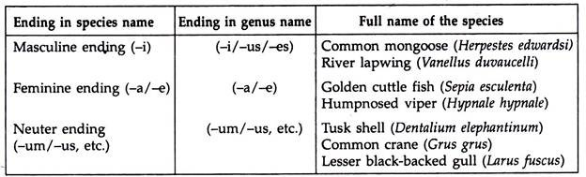
The specific name (species part) indicates distinctness while generic part shows relationship.
5. If the species names are framed after any person’s name, the endings of the species are i, ii and ae, or if the species name are framed after geographical place, the endings of the species are ‘ensis’, ‘iensis’, e.g.:
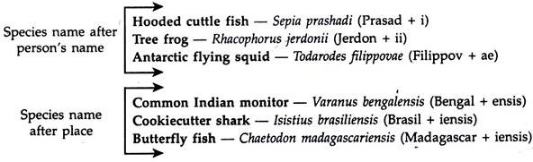
6. First part of a compound species-group name is a Latin letter and denotes a character of the taxon, connected to the remaining part of the name by a hyphen (-), e.g., Sole (a kind of flat fish)—Aseraggodes sinus-arabici. L. Sinus = recess
China-rose (a kind of coloured rose)—Hibiscus rosa-sinensis. L. rosa = rose
7. If a subgenus taxon is used, it is included within parenthesis in between genus and species part and is not included in binomial and trinominal nomenclature, e.g.:
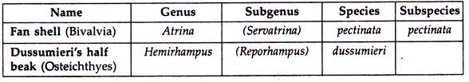
8. The person who first publishes the scientific name of an animal, is the original auther of a name, may be written after the species name along with the year of publication. The author’s name may be in its abbreviated form.
Lion—Felis leo Linnaeus, 1758 Lion—Felis leo Linn., 1758 or Felis leo L., 1758
9. Comma is only used between author’s name and the year of publication (Art. 22. A. 2.1), e.g., the scientific name of Common octopus is Octopus vulgaris Cuvier, 1797. No punctuation marks are considered one to other ends of the name, e.g., “Octopus vulgaris Cuvier, 1797” (Not considered). No diacritic mark, apostrophe (i’) and hypen (-) are used in names. In German word the umlaut sign is removed from a vowel and the letter ‘e’ is inserted after the vowel, e.g., mulleri becomes muelleri.
10. If the original generic name given by the first author who also reported the species name, transfers the species part from one genus to the other, the name of the original author is put within parenthesis, e.g.,
Tiger:
Felis tigris Linnaeus, 1758. At first almost all the members of the cat family were placed under the genus-Felis.
Later the genus Felis was divided into two genera, the genus of the larger cats (tiger, lion, leopard, etc.) is Panthera and smaller cats such as jungle cat, fishing cat, golden cat, etc. are placed under the genus Felis, e.g.:

Lion—Felis leo Linnaeus, 1758 – Lion—Panthera leo (Linnaeus, 1758)
Jungle cat—Felis chaus
11. The names are not acceptable before the publication of Linnaean treatise, Systema Naturae (10th edition) which was published on 1st January, 1758 except the Nomenclature of spiders which starts in 1757. The book Aranei suecici was published by C. Clerck in 1757.
12. The scientific names must be either in Latin or Latinised or so constructed that they can be treated as a Latin word.
13. The scientific names must be italicised in printed form, or underlined in hand written or in typed forms, e.g.
Indian leopard—Panthera pardus fusca (Meyer) [in printed form]
Indian leopard—Panthera pardus fusca [in handwritten or typed forms]
14. All taxa from subgenera level and above must be uninominal (Art. 4.1, 4.2) and are plural nouns for names above genus, and singular nouns for genus and subgenus. Taxon ‘species’ may be used as singular or plural.
15. In case of animals some rules and practices are applied on the basis of zoological codes (Art. 29.2) for the formation of suprageneric taxa from superfamily to tribe, e.g.
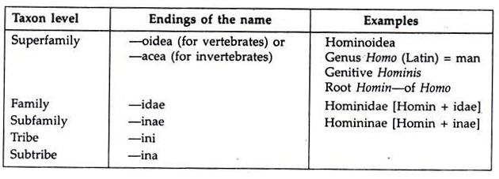
16. A family name should be based on the basis of type-genus, e.g., Chitonidae—Chiton (type genus) + idae = Chitonidae.
17. Two species under a same genus should not have the same name.
18. Nomenclature of a hybrid/hybrids cannot be considered because the hybrids are normally individuals but not population. Thus such names have no status in nomenclature. Hybrids are typically sterile and become synaptic failure during meiosis. They are prevented from back crossing with either parental species.
19. A name published without satisfying the conditions of availability (nomen nudum = naked name) has no standing in zoological nomenclature and is best never recorded, even in synonymy.
20. A scientific valid name which is not used about 50 years in literature, then as per zoological code’s provision the unused senior valid scientific name is treated as obliterated name and junior name which is used continuously in literature (atleast by 10 authors in 25 publications) becomes the accepted official name.

Remark:
The disadvantage of the binominal system is its instability and the name of a species changes every time and is transferred to a different genus (Mayr and Ashlock, 1991).
21. As per the zoological code’s provision (Art. 18), the species and subspecies parts of a name may be same spelling and even the second or the third component of the name repeats the generic name (tautonomy), e.g.:
Scandinavian red fox—Vulpes vulpes vulpes
22. Synonyms are the different names for a same animal or a taxon (species or genus). If the several scientific names are given to a single animal by different scientists, the senior-most name is selected by law of priority. The senior-most or earliest name is called senior synonym (Art. 10.6) and is considered as valid species and the rest of the names are called junior synonyms and are treated as invalid species.
The leopard cat was named Felis bengalensis by Kerr and the same animal was named by Gray, Felis chinensis. Again this animal was named as Prionailurus bengalensis by Kerr. So the first name is Senior synonym and valid and the rest names are junior synonyms and are invalid.
The whale shark was named Rhiniodon typus by Smith in 1828 and the same was named Rhinodon typicus by Muller and Henle in 1839, Micristodus punctatus by Gill in 1865 and Rhinodon pentalineatus by Kishinouye in 1891. Here the first name is considered as senior synonym (Rhiniodon typus) and valid, the rest are junior synonyms and are invalid.
23. Homonyms mean when identical names are given to two or more different taxa. According to the zoological code (Art. 52.2) when two or more homonyms are found, the seniormost (oldest) homonym (Art. 52.2) is used and the junior-most homonyms are replaced with new names, e.g., Cuvier proposed the genus Echidna in 1797 for the spiny anteater.
Forster already proposed the genu Echidna in 1777 for morey eels. According to Law of Priority, Forster s genus claimed senior homonym and Cuvier’s genus considered as junior homonym. Illiger replaced the Cuvier’s name as Tachyglossus for spiny anteater in 1811.
24. Principle of priority:
Of all the rules of zoological nomenclature, it is the most controversial part to choose the correct name when two or more names of a single taxon are discovered. Arbitrariness in nomenclature prevails since the period from 1780-1850. The taxonomists of different countries specially in Europe were unable to consult the names of different taxa during the period of French revolution and Napoleonic wars.
A large number of synonyms appeared on these days. The continuous change of names of different taxa could be prevented when priority was adopted as a basic principle of nomenclature.

Reasons for the Changes of Name:
1. Changes dictated by scientific progress:
(i) Change of the generic part of binomial (binominal).
(ii) Change of specific name.
ADVERTISEMENTS:
(iii) Synonymising of currently accepted species names.
(iv) Analysis of species complex.
2. Changes dictated by rules of nomenclature:
(i) Discovery of an earlier (senior) synonym.
(ii) Discovery of an earlier (senior) homonym.
(iii) Discovery of an earlier genotype fixation.
(iv) Discovery of inapplicable type-specimen.

Law of Priority:
The Law of Priority includes that any name given to a species or genus for the first time (from 1st January 1758 till this day) will be accepted provided:
(i) The specific name is accompanied by an indication or in descriptional figures.
(ii) The author has followed the system of Linnean binominal nomenclature.
(iii) The author has published his contention in a scientific book or journal which has been properly printed and widely circulated.
(iv) In case of a name proposed as a substitute for a name which is invalid by reason of being a homonym, with a reference to the name which is thereby replaced.
(v) In case of the generic or sub-generic name, it should accompany the genotype or sub-generic type fixation.
The Law of Priority in zoological nomenclature is a basic law of International Code and promotes stability. A zoological name and name of a taxon become valid if they belong to the category of senior synonym and senior homonym.
The Law of Priority in zoological nomenclature applies only from subspecies to family category but not to the higher categories. Priority of the zoological name and taxon are considered from the date of publication. Priority means the oldest date, month and year of the publication.

