Characteristics fauna of Himalaya

.Animal life
The fauna of the eastern Himalayas is similar to that of the southern Chinese and Southeast Asian region. Many of those species are primarily found in tropical forests and are only secondarily adapted to the subtropical, mountain, and temperate conditions prevailing at higher elevations and in the drier western areas. The animal life of the western Himalayas, however, has more affinities with that of the Mediterranean, Ethiopian, and Turkmenian regions. The past presence in the region of some African animals, such as giraffes and the hippopotamuses, can be inferred from fossil remains in deposits found in the Siwalik Range. The animal life at elevations above the tree line consists almost exclusively of cold-tolerant endemic species that evolved from the wildlife of the steppes after the uplift of the Himalayas. Elephants and rhinoceroses are restricted to parts of the forested Tarai region—moist or marshy areas, now largely drained—at the base of the low hills in southern Nepal. Asiatic black bears, clouded leopards, langurs (a long-tailed Asian monkey), and Himalayan goat antelopes (e.g., the tahr) are some of the denizens of the Himalayan forests. The Indian rhinoceros was once abundant throughout the foothill zone of the Himalayas but is now endangered, as is the musk deer; both species are dwindling, and few live, other than those in a handful of reserves set up to protect them. The Kashmir stag, or hangul, is near extinction.
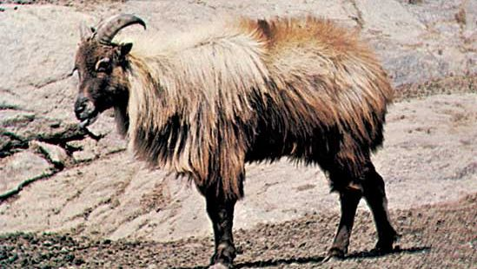
Himalayan tahr
Himalayan tahr (Hemitragus jemlahicus)
Arthur W. Ambler—The National Audubon Society Collection/Photo Researchers
In remote sections of the Himalayas, at higher elevations, snow leopards, brown bears, lesser pandas, and Tibetan yaks have limited populations. The yak has been domesticated and is used as a beast of burden in Ladakh. Above the tree line the most numerous animals, however, are diverse types of insects, spiders, and mites, which are the only animal forms that can live as high up as 20,700 feet (6,300 metres).
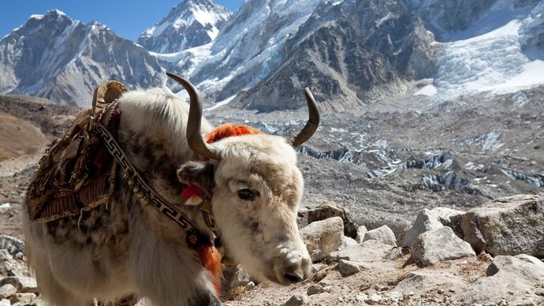
Himalayas: yak
A yak in the Himalayas, Nepal.
© Galyna Andrushko/Fotolia
Fish of the genus Glyptothorax live in most of the Himalayan streams, and the Himalayan water shrew inhabits stream banks. Lizards of the genus Japalura are widely distributed. Typhlops, a genus of blind snake, is common in the eastern Himalayas. The butterflies of the Himalayas are extremely varied and beautiful, especially those in the genus Troides.
Bird life in the Himalayas is equally rich but is more abundant in the east than in the west. In Nepal alone almost 800 species have been observed. Among some of the common Himalayan birds are different species of magpies (including the black-rumped, the blue, and the racket-tailed), titmice, choughs (related to the jackdaw), whistling thrushes, and redstarts. A few strong fliers, such as the lammergeier (bearded vulture), the black-eared kite, and the Himalayan griffon (an Old World vulture), also can be seen. Snow partridges and Cornish choughs are found at elevations of 18,600 feet (5,700 metres).

