Crustaceans: General characters and Classification
Crustaceans (Crustacea /krʌˈsteɪʃə/) form a large, diverse arthropod taxon which includes such animals as crabs, lobsters, crayfish, shrimp, krill, prawns, woodlice, barnacles, copepods, amphipods and mantis shrimp.
The crustacean group can be treated as a subphylum under the clade Mandibulata; because of recent molecular studies it is now well accepted that the crustacean group is paraphyletic, and comprises all animals in the clade Pancrustacea other than hexapods.
Some crustaceans (Remipedia, Cephalocarida, Malacostraca) are more closely related to insects and the other hexapods than they are to certain other crustaceans.
The 67,000 described species range in size from Stygotantulus stocki at 0.1 mm (0.004 in), to the Japanese spider crab with a leg span of up to 3.8 m (12.5 ft) and a mass of 20 kg (44 lb).
Like other arthropods, crustaceans have an exoskeleton, which they moult to grow.
They are distinguished from other groups of arthropods, such as insects, myriapods and chelicerates, by the possession of biramous (two-parted) limbs, and by their larval forms, such as the nauplius stage of branchiopods and copepods.
Most crustaceans are free-living aquatic animals, but some are terrestrial (e.g. woodlice),
some are parasitic (e.g. Rhizocephala, fish lice, tongue worms) and some are sessile (e.g. barnacles).
The group has an extensive fossil record, reaching back to the Cambrian. More than 7.9 million tons of crustaceans per year are produced by fishery or farming for human consumption, most of it being shrimp and prawns.
Krill and copepods are not as widely fished, but may be the animals with the greatest biomass on the planet, and form a vital part of the food chain.
The scientific study of crustaceans is known as carcinology (alternatively, malacostracology, crustaceology or crustalogy), and a scientist who works in carcinology is a carcinologist.

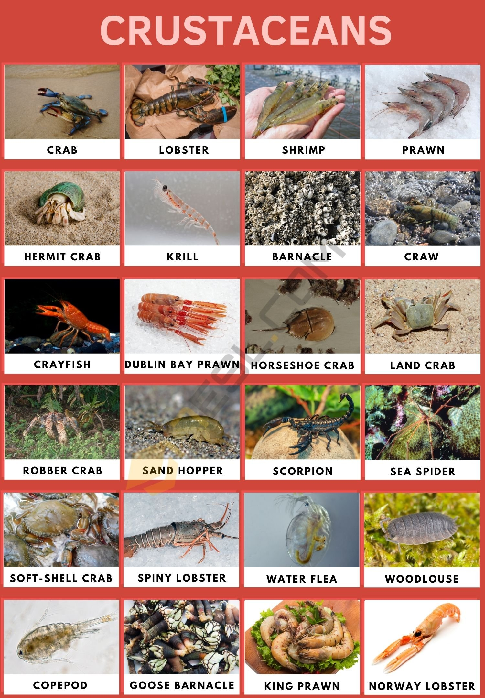

Crustaceans and Humans
Over the years, we have made it our mission to explore some of the more exotic culinary masterpieces on the planet, and we didn’t hold back when we got to crustaceans. There are a plethora of benefits involved in consuming crustaceans that we make use of when we eat them. They also play a rather vital part in the marine food chain, meaning that without them, we would struggle to survive the same way we do today.

Types of Crustaceans

Branchiopoda
Generally comprises crustaceans like shrimp.

Ostracods
The smallest type of crustacean (often referred to as seed shrimp). They typically are only 1mm in size.

Remipedia
A long and blind type of crustacean often found in saline groundwater

Maxillopoda
It’s difficult to group the members of this type by any one characteristic. It’s very diverse and includes barnacles and copepods.

Malacostracan
These are the largest of the groups of crustaceans and the ones most commonly recognized, like crabs and lobsters.
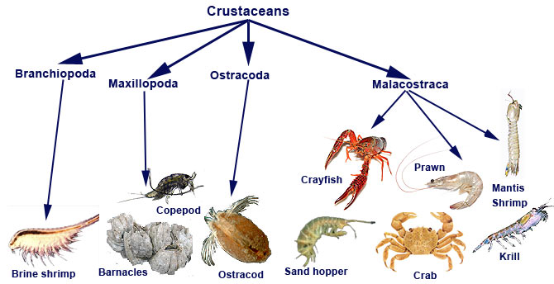

List of Crustaceans

Names of Crustaceans
- Barnacle
- Beach Flea
- Copepod
- Crab
- Craw
- Crayfish
- Dublin Bay Prawn
- Freshwater Shrimp
- Goose Barnacle
- Gribble
- Hermit Crab
- Horseshoe Crab
- King Prawn
- Koura
- Krill
- Land Crab
- Langoustine
- Lobster
- Norway Lobster
- Opossum Shrimp
- Oyster Crab
- Prawn
- Robber Crab
- Sand Hopper
- Sand Shrimp
- Scorpion
- Sea Spider
- Shrimp
- Soft-Shell Crab
- Spiny Lobster
- Water Flea
- Woodlouse

Common Crustaceans | Facts & Pictures

Crab
Crabs are decapod crustaceans of the infraorder Brachyura, which typically have a very short projecting "tail", usually hidden entirely under the thorax. They live in all the world's oceans, in fresh water, and on land, are generally covered with a thick exoskeleton, and have a single pair of pincers.
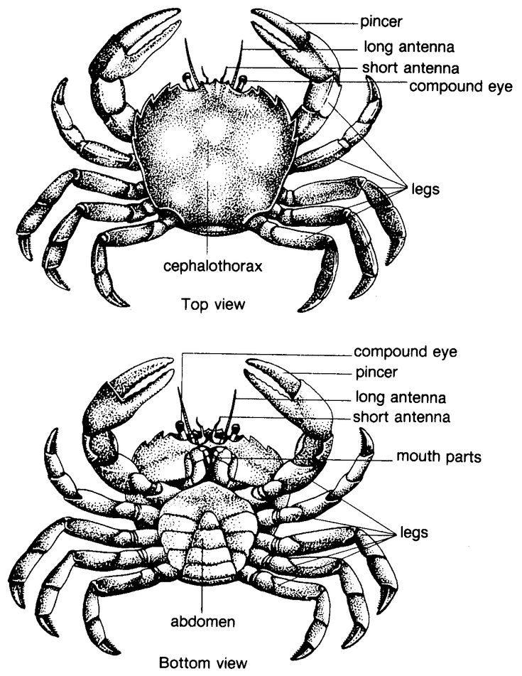
Crabs, although capable of walking in any direction, are most comfortable walking sideways. They are from the decapod family of crustaceans, meaning that they have ten legs. Female crabs are capable of releasing somewhere between 1000 to 2000 eggs at once, though nowhere near that many of their offspring actually survive past the fertilization phase. Smaller crabs have an average lifespan of about 3-4 years.
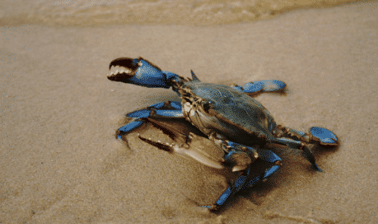

Lobster

Lobsters are a family of large marine crustaceans. Lobsters have long bodies with muscular tails, and live in crevices or burrows on the sea floor. Three of their five pairs of legs have claws, including the first pair, which are usually much larger than the others.
Lobsters are another type of decapod in the crustacean family and perhaps one of the most luxurious food items known to humans. They used to be considered a poor man’s food though and were often fed to pigs rather than the wealthy. Lobsters are also capable of swimming both forwards and backward and can do so depending on danger if they need to.

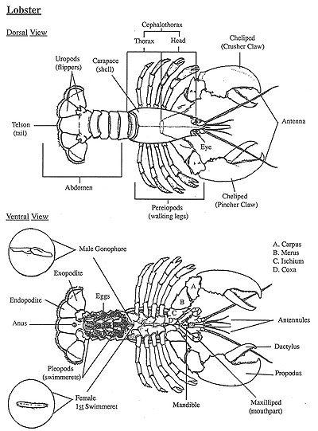
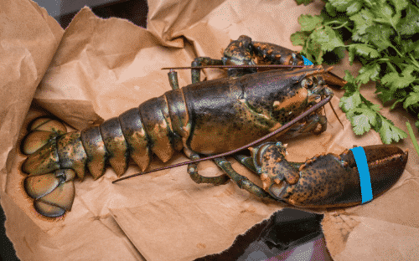

Shrimp
Shrimp are decapod crustaceans with elongated bodies and a primarily swimming mode of locomotion – most commonly Caridea and Dendrobranchiata. More narrow definitions may be restricted to Caridea, to smaller species of either group or to only the marine species.
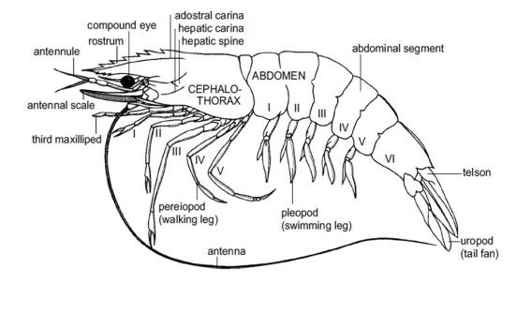With over 2000 species of shrimp living on the planet, they can be found just about anywhere. From the seafloor to a riverbed, shrimp like to get around. They can live somewhere between 1 and 7 years depending on the species and the habitat. They can also range in size (though most people only know them as smaller creatures). They can grow as long as 20cm.
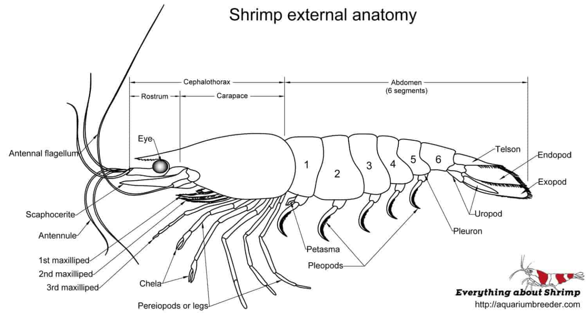
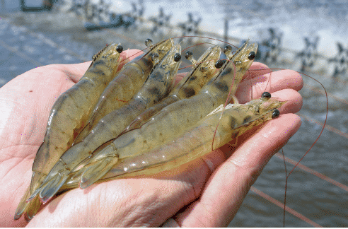

Prawn
A prawn is a small shellfish with a long tail and many legs , which can be eaten
These are very similar in appearance to shrimp but they are two different types of crustaceans. The main difference is that prawns are often larger than shrimp and their branched gill structure. Prawns are more inclined to favor warmer waters too.
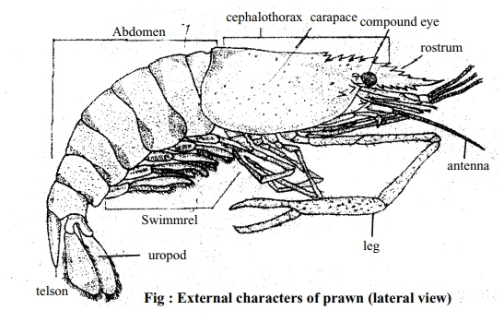
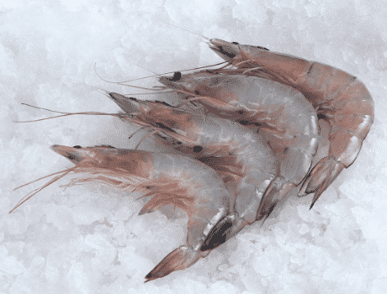

Hermit Crab
Hermit crabs are anomuran decapod crustaceans of the superfamily Paguroidea that have adapted to occupy empty scavenged mollusc shells to protect their fragile exoskeletons. There are over 800 species of hermit crab, most of which possess an asymmetric abdomen concealed by a snug-fitting shell.
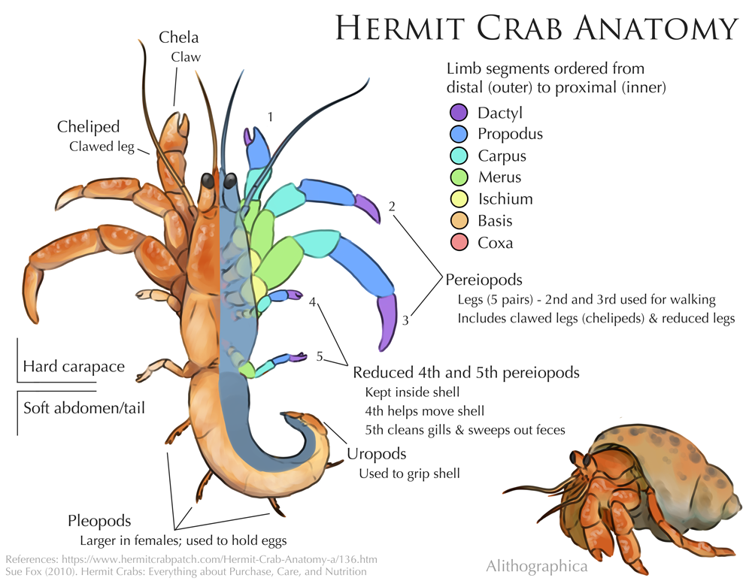Hermit crabs are omnivorous creatures and will eat both algae and dead (or living) animals as they see fit. They aren’t considered true crabs as they aren’t capable of forming their own shell and don’t have a hard exoskeleton. That is why they search for a shell to defend them and carry it on their backs. They are a completely different species of crustacean to a crab.
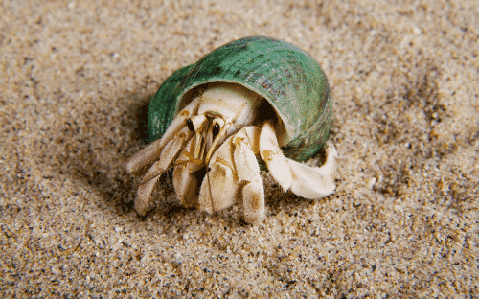

Krill
Krill are small crustaceans of the order Euphausiacea, and are found in all the world's oceans. The name "krill" comes from the Norwegian word krill, meaning "small fry of fish", which is also often attributed to species of fish
Krill are very close to the bottom of the food chain in ocean waters. They feed on phytoplankton and algae and are often fed on themselves by larger fish. In fact, basically, every other species of fish in the ocean feeds on krill, making krill vital for ocean life. They will always travel in hordes of millions, making it much easier for predators to find them, but easier for some of the krill to escape too.
