Annelida
Phylum Annelida is a very broad phylum belonging to the kingdom Animalia. The Annelids are found in aquatic as well as terrestrial environments. These are bilaterally symmetrical invertebrate organisms. Their segmented body distinguishes them from any other organism.
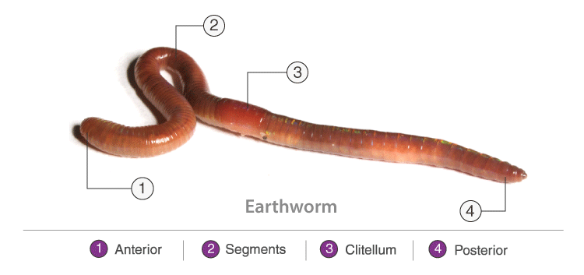
Phylum Annelida

Characteristics of Annelida
The characteristics of the organisms present in the Phylum Annelida are as follows:
- The Annelids are coelomate and triploblastic.
- They exhibit organ system level organization.
- Their body is segmented.
- They respire through their body surface.
- Nephridia are the excretory organs.
- They have a well-developed circulatory and digestive system.
- Their body contains haemoglobin, which gives them a red colour.
- Regeneration is a very common characteristic of the Annelids.
- Setae help them in movement.
- Most of the Annelids are hermaphrodite, i.e., male and female organs are present in the same body. They reproduce both sexually and asexually. The others reproduce sexually.
- Eg., Earthworms, and leeches

Classification of Annelida
Following are the different classification of Annelida:
- Polychaeta
- Oligochaeta
- Hirudinea
- Archiannelida

Polychaeta
- The body is elongated and divided into segments.
- They are found in the marine environment.
- These are true coelomates, bilaterally symmetrical worms.
- They excrete through metanephridia and protonephridia.
- Fertilization is external.
- They have a well-developed nervous system.
- The circulatory system is closed type.
- They are hermaphrodites.
- They might possess fin-like appendages called parapodia.
- The organisms belonging to this group lack clitellum and are dioecious.
- Eg., Nereis, Syllis

Oligochaeta
- They are mostly freshwater and terrestrial organisms.
- The body is segmented metamerically.
- Head, eyes and tentacles are not distinct.
- They are hermaphrodites, but cross-fertilization takes place.
- Fertilization is external.
- Cocoon formation occurs.
- Setae are segmented.
- They do not possess parapodia but clitellum is present.
- The organisms belonging to this class are monoecious.
- They exhibit no free larval stage and the development takes place inside the cocoons.
- Eg., Pheretima, Tubifex

Hirudinea
- Most commonly found in freshwater. Some are marine, terrestrial, and parasitic.
- The body is segmented.
- The tentacles, parapodia, and setae are not present.
- The animals are monoecious.
- The body is dorsoventrally or cylindrically flattened.
- They have an anterior and posterior sucker on the ventral side.
- The organisms lay eggs in cocoons.
- There is no larval stage during the development of the organism.
- The mouth is located ventrally in the anterior sucker, while the anus is present dorsally in the posterior sucker.
- Fertilization is internal.
- They are hermaphrodites.
- Eg., Hirudinaria

Archiannelida
- They are found only in the marine environment.
- The body is elongated without setae and parapodia.
- They are unisexual or hermaphrodite.
- Tentacles are present on the prostomium.
- Eg., Dinophilus, Protodrilus
In conclusion, members of Phylum Annelida have bodies that are segmented, such as leeches and earthworms

