General Characterise Mollusca
The animals belonging to the phylum Mollusca have soft-bodies, triploblastic and bilaterally symmetrical and coelomate. The study of Mollusca is called Malacology. They are sluggish invertebrates, with a thin fleshy envelope or mantle covering the visceral organs.
The term Mollusca was derived from the term given by Aristotle to cuttlefish. Mollusc means soft.
These organisms are found in the terrestrial as well as in deep seas. Their size ranges from microscopic organisms to organisms 20 metres long.
They play a very important role in the lives of humans. They are a source of jewellery as well as food. Natural pearls are formed within these molluscs.
The bivalve molluscs are used as bioindicators in the marine and freshwater environments. But few of them such as snails and slugs are pests.
They are a source of food as well as jewellery. The hard shells are used to make beautiful jewellery pieces. In some regions of the world, these are also raised as pets, even though it sounds bizarre.
Pearls that are obtained from bivalves and gastropods are valuable as these pearls are lined with nacre. Natural pearls are formed when a small foreign object gets stuck in between the mantle and shell of the mollusc.
The bivalve molluscs are used as bioindicators of the freshwater and marine environments. But not all molluscans are good for humans.
Some are pests like the snails and slugs.
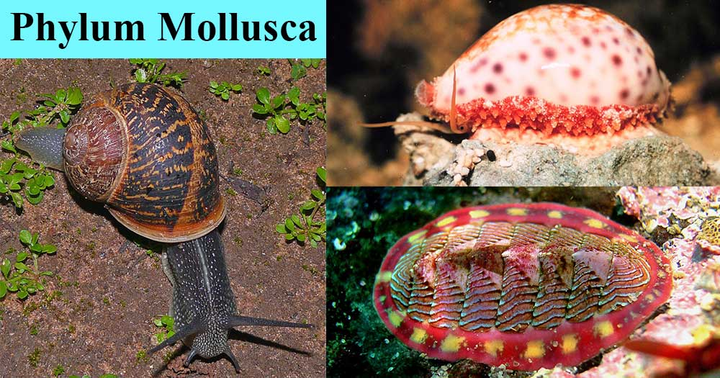
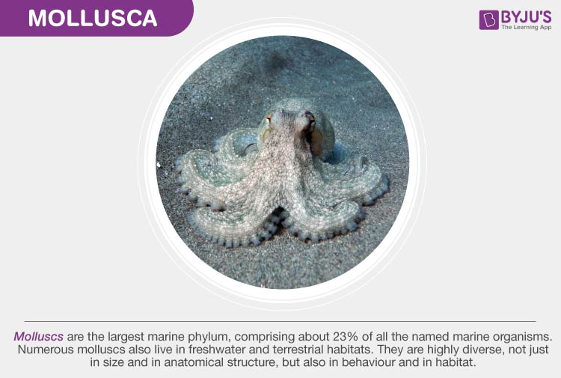
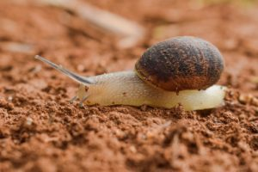
Mollusca Characteristics

Phylum Mollusca (Mollusks) Characteristics
- They are essentially aquatic mostly marine, few freshwater and some terrestrial form.
- They may be found as hidden parasites in the interior of other animals.
- They vary in size from giant squids and clams to little snails, a millimeter long.
- They have at least two characters radula and mantle not found elsewhere.
- The body is soft, unsegmented (except in Monoplacophora), bilaterally symmetrical, coelomate, triploblastic.
- They have tissue-system grade of body organization
- The body consists of head, foot, mantle, and the visceral mass.
- The body is clothed with one-layered often ciliated epidermis.
- The body is commonly protected by an exoskeleton calcareous shell of one or more piece secreted by the mantle.
- Head is distinct, bearing mouth, eyes, tentacles and other sense organs except in pelecypoda and scaphodoa.
- The ventral body is modified into a muscular plough-like surface, the foot which is variously modified for creeping, burrowing and swimming.
- Mantle or pallium is a fold of a body wall that leaves between itself the main body, mantle cavity.
- The visceral mass contains the vital organs of the body in the compact form taking the form of dorsal humps or dome.
- The body cavity is hemocoel. The coelom is reduced and represented mainly by the pericardial cavity, gonadial cavity, and nephridia.
- The digestive tract is simple with anterior mouth and posterior anus but in gastropods, scaphodos, and cephalopods the intestine becomes U-shaped bringing anus to anterior part.
- Rasping organs, radula usually present, except in pelecypoda.
- The circulatory system is open type except in cephalopods.
- Respiratory organs contain numerous gills or ctenidia usually provided with osphradiuma at the base. The lung is developed in terrestrial forms.
- Respiration is direct or by gills or lungs or both.
- Haemocyanin is their respiratory pigments.
- Excretion is by paired metanephridia (kidney).
- The nervous system consists of paired cerebral, pleural, pedal and visceral ganglia joined by longitudinal and transverse connections and nerves. Ganglia usually form a circumenteric ring.
- Sense organs consist of eyes, statocysts, and receptors for touch, smell, and taste.
- Sexes are usually separate (dioecious) but some are monoecious (hermaphroditic).
- Fertilization is external or internal.
- Development is direct or with metamorphosis through the trochophore stage called veliger larva.

Phylum Mollusca Classification
Mollusca (mollusks) are classified into 6 classes according to their symmetry and the characters of food, shell, mantle, gills, nervous system, muscles, and radula.

Class 1. Monoplacophora (Gr., monos, one+ plax, plate+ pherein, bearing)
- Body is bilaterally symmetrical and segmented.
- Mantle dome-shaped.
- The shell comprises a single piece or valve.
- Flattened limpet-shaped shell with spirally coiled Protoconch.
- Head without eyes and tentacles.
- Mantle encircles the body as a circular fold of the body.
- Foot broad and flat, with 8 pairs of pedal retractor muscles.
- Gills external. 5 pairs of gills in pallial grooves.
- 6 pairs of nephridia, two of which are gonoducts.
- Radula in a radular sac; intestine much coiled.
- Heart of 2 pairs of auricles and a single ventricle.
- Nervous system with longitudinal pallial and pedal cords.
- Sexes separate (dioecious)
- Examples: Neopilina galatheae.
- 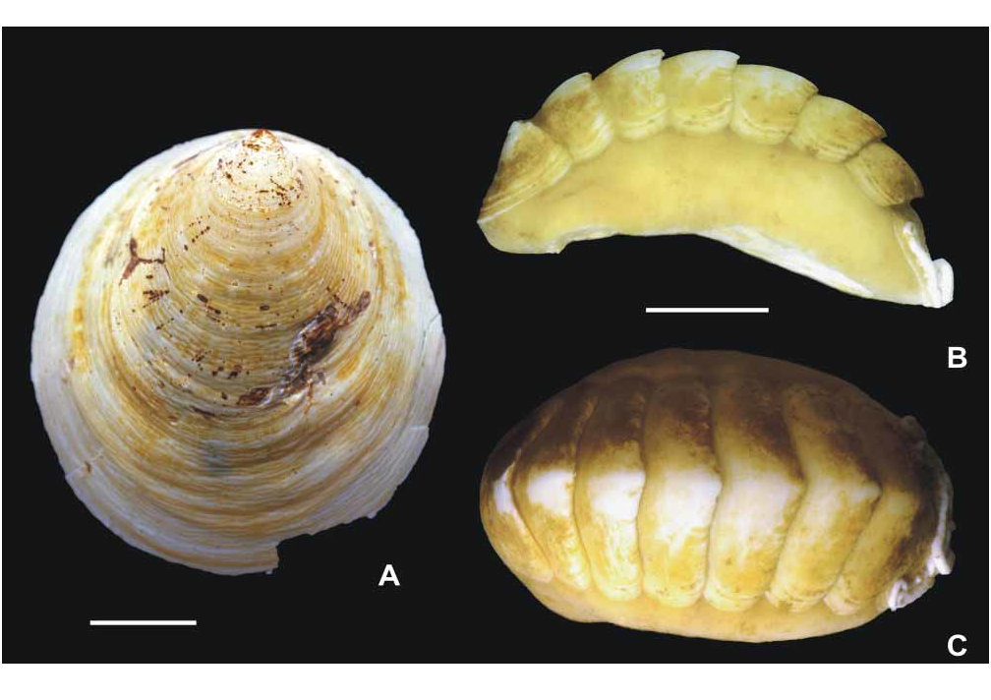
- 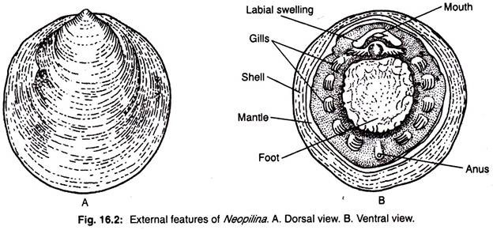

Top of Form
Bottom of Form

Class 2. Amphineura (Gr., amphi, both + neuron, nerve)
- Body elongated with reduced head.
- Radula present.
- Shell as 8 dorsal plates or as spicules.
- Ventral foot, large, flat and muscular.
- Non- ganglionated nerve ring around the mouth with 2 pairs of the interconnected nerve cord.
- External fertilization: trochophore larva.
Subclass 1. Aplacophora
- Worm-like body with mantle
- No shell and foot.
- Calcareous spicules buried in the cuticle.
- Simple radula; marine cavity posterior, some with a pair of bipectinate ctenidia.
- Examples: Neomenia, Nematomein, Chaetoderma.
Subclass 2. Polyplacophora
- Dorso-ventrally flattened body; small head
- No eyes and tentacles.
- Radula, mantle, foot and external gills present.
- Posterior mantle cavity.
- Shell as 8 calcareous dorsal plates.
Order 1. Lepidopleurina
- Valves of the shell without insertion plates.
- Ctenidia a few and posterior.
- Examples: Lepidopleurus.
Order 2. Chitonida
- Valves of the shell with insertion plates.
- Gills along the whole length of mantle grooves
- Examples: Chaetopleura, Chiton, Ischnochiton.

Class 3. Scaphopoda (Gr., Scapha, boat + podos, foot)
- Exclusively marine.
- The body is bilaterally symmetrical, elongated and enclosed in a tusk-shell opens at both ends.
- No head; mouth with tentacles; no eyes.
- Conical foot, radula present; no gills.
- Mantle tubular completely enclosing the body.
- Mouth surrounded by lobular processes or outgrowths.
- Heart rudimentary.
- Kidneys paired; gonad single.
- Sexes separate(dioecious).
- Trochophore larva.
- Examples: Dentalium, Cadulus, Pulsellum.

Class 4. Gastropoda (Gr., gaster, belly + podos, foot)
- Marine, freshwater, terrestrial and few parasitic on echinoderms.
- Body unsegmented, asymmetrical typically with univalve, spirally coiled
- Head distinct bearing tentacles, eyes, and mouth.
- The foot is ventral, broad, flat and muscular forming the creeping sole and often bearing dorsally a hard piece, the operculum on its posterior end.
- Torsion (coiling) of body mass at sometimes in development.
- The mantle is a collar-like fold of body wall lining the body leaving a space, the mantle cavity, between itself and the body.
- The buccal cavity contains an odontophore with a radula bearing rows of chitinous teeth.
- The digestive system comprises muscular pharynx, long esophagus, stomach, long coiled intestine, and anteriorly placed anus.
- Respiration by gills (ctenidia) in most forms, through the wall of the mantle cavity in some forms and in many by
- The open circulatory system and heart is enclosed in a pericardium.
- The excretory system comprises metanephridia which are paired in primitive forms and reduced to a single nephridium in most forms.
- The nervous system comprises distinct cerebral and pleural besides buccal, pedal, parietal and visceral ganglia.
- Sexes separate (dioecious) in most forms while in some forms united.
- The development includes trochophore and veliger
Subclass 1. Prosobranchia(streptoneura)
- Mostly marine, few freshwater or terrestrial forms.
- Owing to torsion of the visceral mass, the visceral nerve commissures are twisted into a figure of “8”.
- Head with a single pair of tentacles.
- Mantle cavity opens anteriorly in front of the visceral mass.
- Shell closed by an operculum borne on foot.
- The foot is muscular, forms the ventral parts of the body.
- 2 ctenidia in mantle cavity situated anterior to the heart.
- Sexes separate (Dioecious); gonad single; larvae trochophore or veliger.
Order 1. Archaeogastropoda (Aspidobranchia)
- Prosobranchs without proboscis, siphon, penis and prostatic glands.
- One or two bipectinate ctenidia.
- The operculum is also absent in many forms with few exceptions.
- Shell usually coiled.
- 2 kidneys and heart with 2 auricles.
- 2 osphradia usually present.
- Nervous system not concentrated, with pedal cord.
- Sex cells discharged directly into the sea by way of the right nephridia.
- Examples: Fissurella (key-hole limpet), Trochus (top shell), Haliotis, Acmaea, Patella, Turbo.
Order 2. Mesogastropoda (Pectinibranchia)
- Prosobranchs usually with siphon, penis and a non-calcified operculum.
- One auricle, one kidney, and one mono-pectinate ctenidium.
- Radula taenioglossate type having 7 teeth in each row.
- Single ospharadium.
- A nervous system without pedal cords.
- Fertilization is internal; larva usually a free-swimming veliger.
- Mostly marine, some freshwater.
- Examples: Crepidula (slipper shell), Pila (apple snail), Natica (star shell), Hydrobia, Jonthina, Viviparus.
Order 3. Neogastropoda (Stenoglossa)
- Shell with a short to a very long siphonal canal.
- Radula consists of rows with 2 or 3 teeth in each row.
- Nervous system concentrated.
- Osphradium is large.
- Free-swimming veliger suppressed.
- Examples: Murex, Nassarius, Oliva, Magilus, Buccinum.
Subclass 2. Opisthobranchia
- Exclusively marine gastropods.
- Shell small without operculum or no shell.
- Shell when present covered with mantle or pedal cord.
- Body mass torted or detorted.
- Gills posterior to the heart.
- Heart with one auricle posterior to the ventricle.
- One kidney, one gonad.
- The nervous system concentrated due to detorsion.
- Monoecious; larva veliger.
Order 1. Cephalaspidea
- Shell present but may be partly or wholly enclosed by the mantle.
- Head with the tentacular shield.
- Lateral parapodial lobes prominent.
- Examples: Acteon, Hydatina, Bulla.
Order 2. Anaspidea
- Found mostly in tropical or subtropical waters.
- Shell usually reduced or less covered by mantles.
- Well-developed parapodial lobes.
- Anterior end bears a pair of tentacles, a pair of rhinophores and a pair of eyes.
- Sperm ducts open, running the body length to the penis located anteriorly.
- Examples: Aplysia, Akera.
Order 3. Pteropoda
- Pelagic snails with or without a shell.
- Parapodial fins for swimming.
- With or without a mantle cavity.
- Head with a pair of rhinophores.
- Protandrous, hermaphrodites with an open sperm groove.
- Examples: Spiratella, Cavolina, Clione, Peraclis.
Order 4. Sacoglossa
- With or without the shell.
- The pharynx is suctorial.
- Sperm duct closed.
- Parapodia and cerata present.
- Examples: Oxynoe.
Order 5. Acochilidiacea
- Minute to small-sized.
- Without shell or naked snail.
- Gills, parapodia and visceral sac projecting behind the foot.
- Sexes united or separate in a few.
- Inhabit coarse sand.
- Examples: Acochlidium.
Order 6. Notaspidea
- Shell external or reduced and internal.
- Parapodia absent.
- Mantle, but no mantle cavity.
- Gills bipectinate and osphradium on the right side.
- Examples: Tylodina, Pleurobranchus.
Order 7. Nudibranchia
- Shell absent or naked.
- Internal gills, mantle cavity and osphradium absent.
- Various dorsal growth.
- Respiration by secondary branchiae usually arranged in a circlet around the anus.
- Examples: Doris, Eolis, Tritonia, Armina.
Order 8. Pyramidellacea
- Shell typically spirally twisted.
- Operculum absent.
- Gills and radula are absent.
- Long invaginable proboscis.
- Semi- parasitic.
- Examples: Turbonilla, Odostomia.
Order 9. Philinoglossacea
- Minute naked snail.
- No gills and head appendages.
- Visceral mass separated from the foot only by a shallow groove.
- Examples: Philinoglossa.
Order 1o. Rhodopacea
- Vermiform snail.
- Without external appendages.
- Nephridia Protonephridial type.
- Anus on the right side of the body.
- Examples: Rhodope.
Order 11. Onchidiacea
- Slug-like, naked without shell opisthobranchs.
- Mantle projects widely beyond foot.
- Head bears a pair of retractile tentacles each tipped with an eye.
- Pulmonary sac, anus and female gonopores located at the posterior end.
- Male gonopore located anteriorly.
- Examples: Onchidium, Onchidella.
Order 12. Parasita
- Endoparasitic gastropods found in the interior of holothurians.
- Extremely degenerated snails.
- Shelled embryos.
- Examples: Entoconcha, Thyonicola.
Subclass 3. Pulmonata
- Mostly freshwater or terrestrial, a few marine forms.
- Shell typically spiral or reduced or absent, if present partly or completely concealed by the mantle.
- Np operculum.
- Mantle cavity transformed into a pulmonary sac with a narrow pore on the right side.
- Gills absent.
- Heart with one auricle anterior to the ventricles.
- Nervous system secondarily symmetrical owing to the shortening or connectives and concentration of ganglionic complex.
Order 1. Basommatophora
- Freshwater, brackish water and marine forms.
- Shell delicate with a conical spire and large aperture.
- One pair of non-invaginable tentacles with eyes at their bases.
- Male and female gonopore generally separate.
- Examples: Siphonaria, Lymnaea, Planorbis.
Order 2. Stylommatophora
- Terrestrial pulmonates.
- Shell with conical spire, internal or absent.
- 2 pairs of invaginable or retractile tentacles with eyes at tips of the posterior pair.
- Male and female gonopore usually united.
- Examples: Limax, Helix, Partula, Retinella.

Class 5. Pelecypoda (Gr., pelekus, batchet+ podoa, foot)
- Aquatic, mostly marine, some freshwater forms.
- The body is bilaterally symmetrical and laterally compressed.
- Bivalve shells hinged together and mid-dorsally.
- Head is not distinct; pharynx, jaws, radula, and tentacles
- The foot is ventral, muscular which is ploughshare.
- Mantle bilobed, consisting of paired, right and left lobes.
- Gills or ctenidia are paired, one on each side.
- The coelom is reduced to a dorsally placed pericardium.
- The alimentary canal is coiled with large paired digestive glands.
- The heart is contained within the pericardium and comprises a median ventricle and two auricles.
- The excretory organ is paired nephridia or kidneys opens at one end into pericardium at the other end to the exterior.
- The nervous system consists typically of 4 pairs of ganglia i.e. cerebral, pleural, pedal and visceral.
- Cerebral and pleural of each side usually fused into a single Cerebro-pleural ganglion.
- Sense organs are statocyst and osphradia.
- Sexes are separate or united.
- Mostly filter-feeding.
- Development is accompanied by metamorphosis which usually includes a trochophore larva.
Order 1. Protobranchia
- Single pair of plate-like ctenidia each consisting of 2 rows of flattened gills filaments.
- Mouth placed at the base of muscular proboscides.
- Stomach with style sac.
- The foot is not compressed but has a flattened ventral surface or sole for creeping.
- Two adductor muscles present.
- Examples: Nucula, Solenomya.
Order 2. Filibranchia
- Single pair of plume-like gills formed of distinct V-shaped filaments.
- Chitinous gastric shield in the stomach developed.
- Style sac with crystalline style.
- Inter-filamentar junctions are either absent or formed by groups of inter-locking cilia.
- The inter-lamellar junction is either absent or non-vascular.
- Two adductor muscles present, anterior may be reduced or absent.
- Foot small or poorly developed.
- Examples: Mytilus, Arca.
Order 3. Pseudolamellibranchia
- Gills are plaited so as to form vertical folds.
- Inter-filamentar junctions may be ciliary or vascular.
- Inter-lamellar junctions are vascular and non-vascular.
- Single large posterior adductor muscle present.’
- Shell valve are frequently equal.
- Foot rudimentary of feebly developed.
- Examples: Pecten, Ostraea, Melagrina.
Order 4. Eulamellibranchia
- Gills are firm and basket-like.
- Gills filaments reflexed and fused completely to form tissue sheets.
- Gills function for food gathering.
- Gills muscles are united by vascular inter-filamentar and inter-lamellar junctions.
- Siphon of small or large size present.
- Foot large, byssus small or absent.
- Style sac short.
- Examples: Anodonta, Unio, Cardium, Venus, Mya, Teredo.
Order 5. Septibranchia
- No gills.
- Two adductor muscles present.
- Stomach lined by chitin; style sac reduced.
- Footlong and slender and byssus rudimentary or absent.
- Sexes united.
- Examples: Poromya, Cuspidaria.

Class 6. Cephalopoda (=Siphonopoda) (Gr., kephale, head+ podos, foot)
- Marine and free-swimming.
- The body is bilaterally symmetrical with head and trunk.
- Body elongated dorso-ventrally.
- Shell external, internal or absent.
- Head distinct and large with well-developed eyes and mouth.
- The trunk consists of the symmetrical and uncoiled visceral mass.
- Mantle encloses posteriorly and ventrally a large mantle cavity.
- Foot altered into a series of suckers bearing arms or tentacles encircling the mouth.
- Moth bears jaws and radula.
- 2 or 4 pairs of bipectinate gills.
- Circulatory system closed, heart with 2 or 4 auricles.
- The excretory system comprises 2 or 4 pairs of nephridia.
- The nervous system is highly developed and the principal ganglia are concentrated around the esophagus.
- Sexes separate.
- Development meroblastic without metamorphosis.
Subclass 1. Nautiloidea (=Tetrabranchia)
- Shell external, spiral and chambered.
- Recent species with many suckers fewer tentacles.
- The main part of the foot encircling the mouth, divided into lobes bearing numerous tentacles.
- The funnel does not form a complete tube.
- 4 ctenidia or gills, 4 kidneys and 4 auricles present.
- Ink glands and chromatophores are absent.
- Eyes are simple.
- Examples: Nautilus.
Subclass 2. Smmonoidea
- Shell external and coiled with complex septa and sutures.
- Examples: Pachydiscus.
Subclass 3. Coeloidea (=Dibranchia)
- Shell usually internal and reduced, enveloped by mantle, when external its cavity is not divided by septa.
- The main part of the foot is modified into 8 or 10 suckers bearing arms encircling moth.
- The funnel forms a complete tube.
- 2 ctenidia or gills, 2 kidney, 2c auricle, and 2 branchial heart presents.
- Ink gland duct and chromophores present.
- Eyes are complex in structures.
Order 1. Decapoda
- Body elongated often with lateral fins.
- 10 arms- 2 elongated and called tentacles bearing suckers at their distal ends and 8 short arms bear stalked suckers provided with horny rims.
- Shell is internal and well-developed.
- Nidamental glands are usually present.
- Herat enclosed in the well-developed coelom.
- Examples: Sepia, Loligo, Spirula.
Order 2. Octopoda
- Body globular and without fins.
- 8 arms with sessile suckers and devoid of horny rims.
- Shell absent except in female Argonauta.
- Nidamental glands absent.
- The heart does not lie in the reduced coelom.
- Examples: Octopus, Agronauta.

