Roundworms
Roundworms are parasites that need to live in the body. These parasitic infections can cause diarrhea and fever. Types of roundworms in humans include pinworms and ascariasis.
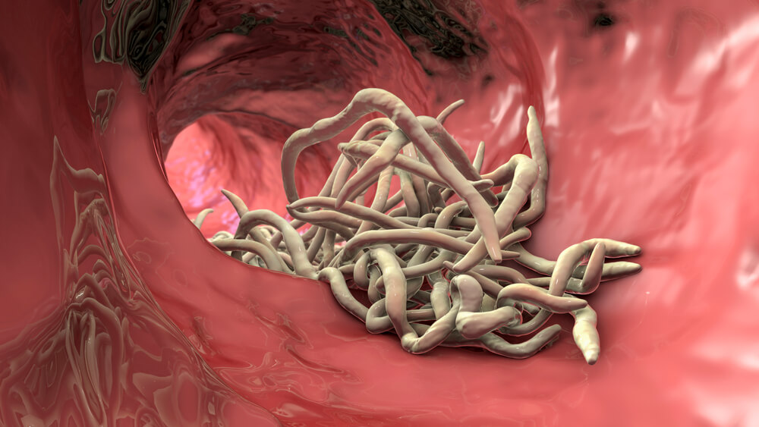

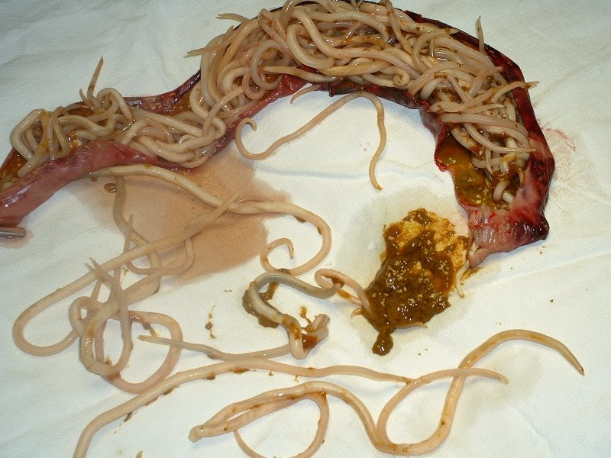
Often, roundworm infections come from traveling to countries with poor sanitation and hygiene. But kids can get them in the U.S. too. Medication can treat roundworms.
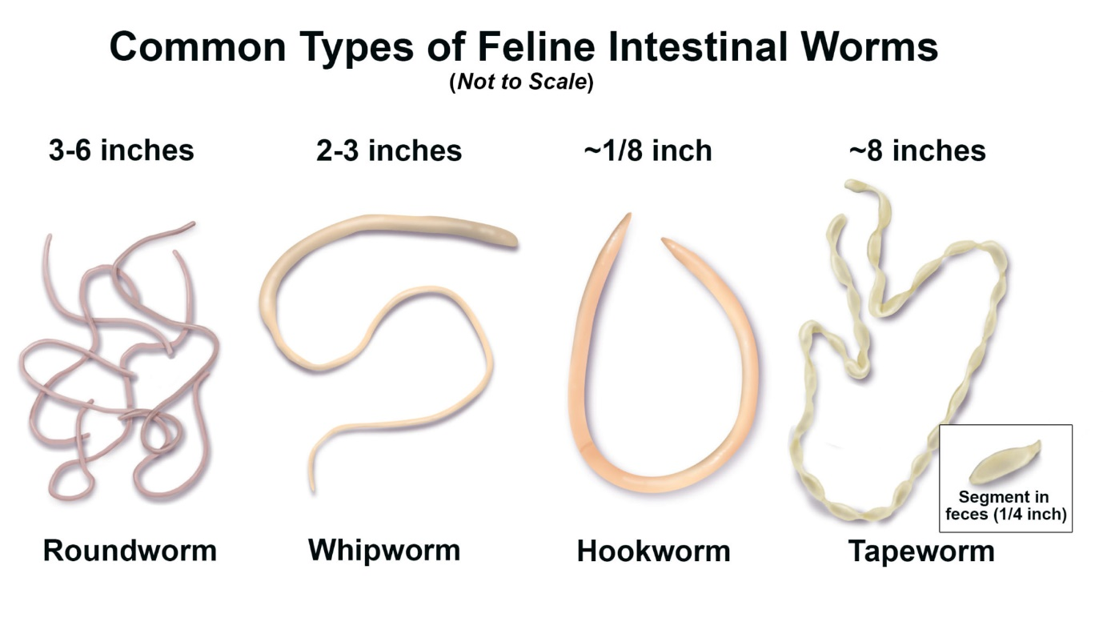

What is a parasite?
Roundworms are parasites — organisms that need to live on or in another creature to survive. Often, the parasite causes problems for its host (creature it depends on). For roundworms, they need the body of humans or other animals to mature into egg-laying adults.

How common are roundworms?
Hundreds of millions of people around the world are infected with roundworms at any given time. But many of these parasites are uncommon in the United States. Americans may come into contact with them when traveling to certain countries.
Pinworms are the most common roundworm infection in the United States. It affects 20 million to 42 million people, many of them children.

How does a person get infected with roundworms?
The route into the body depends on the type of roundworm. Many of these parasites enter the body through the mouth. Infection often happens from touching poop or soil that's infected with eggs and not washing hands (fecal-oral route). Pinworm infections result from touching eggs laid near the opening of the buttocks (anus).
You can accidentally ingest roundworm eggs by preparing food or touching soil that's contaminated. The eggs then hatch inside your body.
For other roundworms, eggs may hide in the food people eat. And in some cases, larvae can enter the body directly through your skin.
Regardless of how they enter, most roundworms end up in your intestines, causing infection or disease.

General Characters of Roundworms
Roundworms make up the phylum Nematoda. The nematodes or roundworms constitute the phylum Nematoda (also called Nemathelminthes), This is a very diverse animal phyla. It has more than 80,000 known species.
Roundworms are small organisms that can live in your intestine, which is part of your digestive system.
Roundworms can live in the human intestine for a long time. They can be harmful and cause many problems, including abdominal (belly) pain, fever and diarrhea.
Roundworms have long, round bodies and can be of different sizes, depending on the type. The eggs or larvae (newly hatched roundworms) often live in infected soil or stool (poop).

Structure and Function of Roundworms
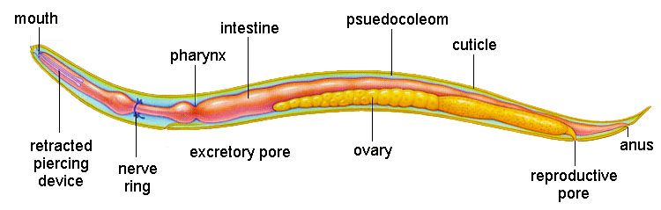
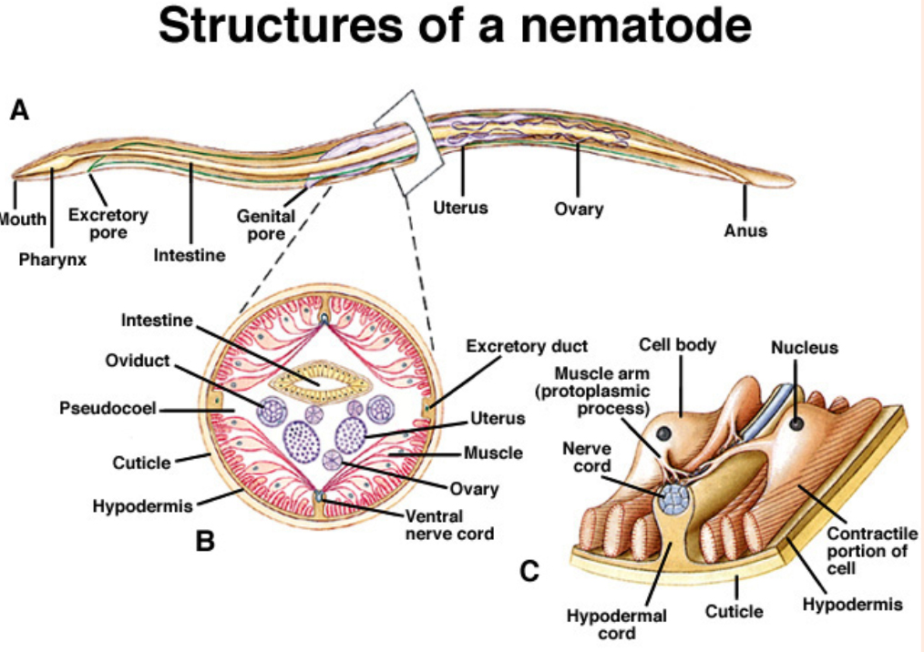
Roundworms may be free-living or parasitic. Free-living worms are found mainly in freshwater habitats. Some live in soil.
They are ubiquitous in freshwater, marine, and terrestrial environments,
They generally feed on bacteria, fungi, protozoans, or decaying organic matter. By breaking down organic matter, they play an important role in the carbon cycle.
Roundworms range in length from less than 1 millimeter to over 7 meters (23 feet) in length. As their name suggests, they have a round body. This is because they have a pseudocoelom. This is one way they differ from flatworms.
Another way is their complete digestive system. It allows them to take in food, digest food, and eliminate wastes all at the same time.
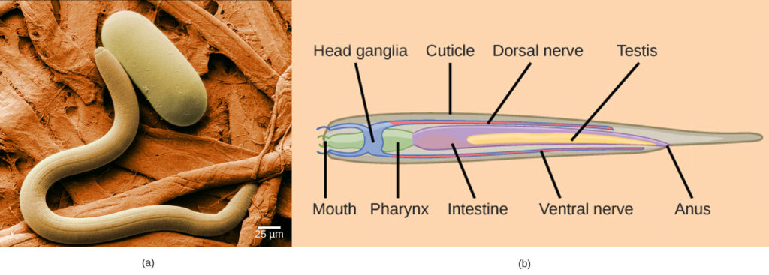
Roundworms have a tough covering of cuticle on the surface of their body. It prevents their body from expanding. This allows the build-up of fluid pressure in the pseudocoelom.
As a result, roundworms have a hydrostatic skeleton. This provides a counterforce for the contraction of muscles lining the pseudocoelom. This allows the worms to move efficiently along solid surfaces.
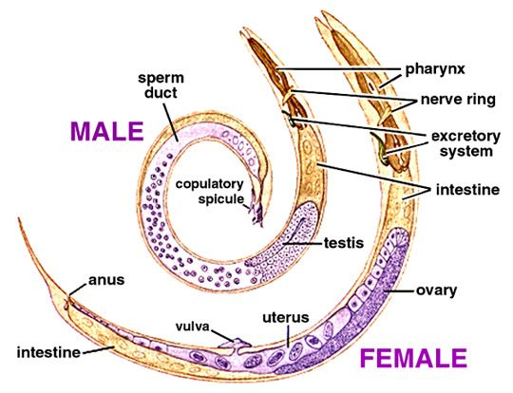
Sexes are separate and reproduce sexually. Sperm and eggs are produced by separate male and female adults. Fertilization takes place inside the female organism.
Females lay huge numbers of eggs, sometimes as many as 100,000 per day! The eggs hatch into larvae, which develop into adults. Then the cycle repeats.
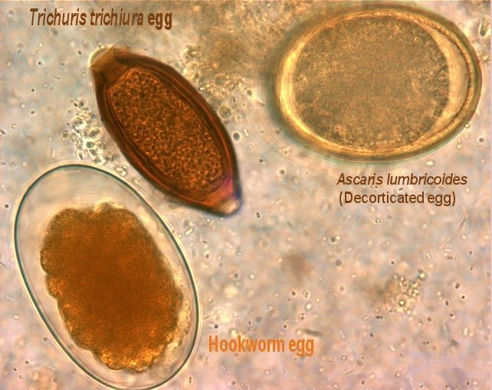
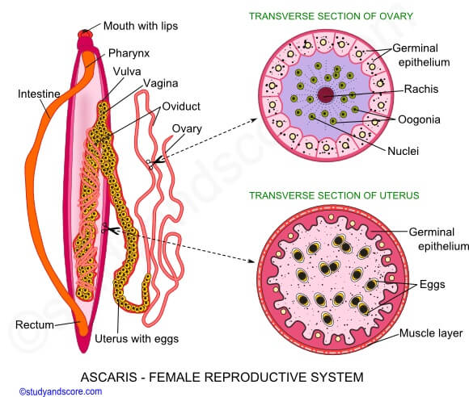

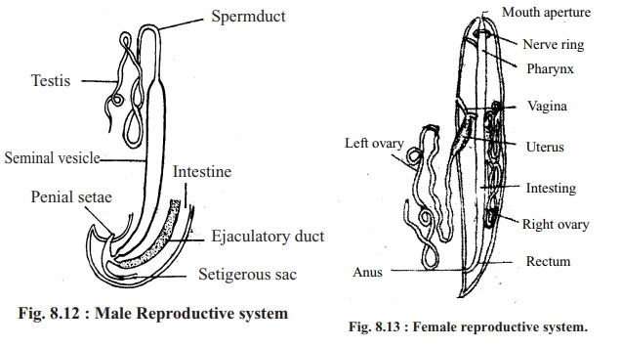

Characteristics of round worms:-
- They maybe free -living, aquatic and terrestrial or parasitic in plant2 and animals.
- They have organ-system level of body organization.
- They are bilaterally symmetrical, triploblastic and pseudo corporate animal.
- Their body is bilaterally symmetrical and triploblastic.
- They are cylindrical in shape.
- Their body has a cavity or pseudocoelom.
- The alimentary canal is distinct, complete with a well developed muscular pharynx, mouth and the anus.
- They are sexually dimorphic.
- They are devoid of the circulatory system and respiratory system.
- Parasitic nematodes cause diseases in the host.
- Their cuticle moults periodically.
- The epidermis is synctical and contains dorsal or ventral nerve cords.
- The body-wall muscles are longitudinal.
- They possess amoeboid sperm cells.
- They consist of chemosensory organs called aphids situated on the lips.
- An excretory removes body wastes from the body cavity through the excretory pore.
- Sexes are separate(dieocious).
- Fertilization is internal and reproduction is sexual, development may be direct.

Classification of Nematodes
Nematodes are classified into the following classes:

Phasmidia or Secernentea
- These are mostly parasitic.
- Caudal glands are absent.
- Unicellular, pouch-like sense organs called plasmids are present.
- The excretory system has paired lateral canals.
- Eg., Ascaris, Enterobius
The class Phasmidia is divided into the following orders:

Rhabditida
- They have smooth and ringed cuticle.
- There is a posterior lobe at the pharynx.
- They are free-living and parasitic.
- Males have copulatory spicules.
- Eg., Rhabditis

Strongylida
- They are vertebrate parasites devoid of lips.
- The pharynx has no bulb.
- They have a well-developed buccal capsule.
- They possess a true copulatory bursa.
- For eg., Strongylus

Oxyurida
- They can be small or moderate in size.
- Males have copulatory spicules.
- Caudal alae are present.
- They can be invertebrates or vertebrates.
- The mouth consists of 3-4 simple lips.
- For eg., Oxyuris

Ascaridida
- These are oviparous, large stout nematodes living as parasites in the intestine of the vertebrates.
- The pharynx may or may not contain a posterior bulb.
- Mouth possess 3 prominent lips.
- There is no buccal capsule.
- For eg., Ascaris

Spirurida
- These are thread-like organisms that vary in size from moderate to large.
- The pharynx is devoid of bulb.
- The females are larger than males and can be oviparous or viviparous.
- The mouth contains two prominent lips.
- For eg., Spirura

Trichuroida
- These are commonly known as whip-worms.
- They possess a slender pharynx.
- The mouth is devoid of lips.
- For eg., Trichuris

Camallanida
- These are oviparous, thread-like organisms.
- The males have no bursa.
- The bursa of adult females is degenerated.
- For eg., Camallanus

Aphasmidia or Adenophorea
- They are free-living organisms.
- The excretory system has no lateral canals.
- Caudal glands are present.
- Phasmids are absent.
- Eg., Capillaria, Trichinella
The class Aphasmidia or adenophorea is divided into the following orders:

Enoplida
- They are mostly marine.
- The cuticle contains bristles.
- These are Cyanthiform amphids.
- For eg., Anticoma

Dorylaimida
- The cuticle is smooth without any bristles.
- These are mostly terrestrial.
- The buccal cavity consists of a protrusible spear.
- It consists of 6-10 labial papillae.
- For eg., Trichodoris

Mermithida
- The cuticle is smooth.
- Amphids are reduced.
- In the larval stage, they live as parasites, whereas, the adult stage is free-living.
- For eg., Mermis, Agamermis

Chromedorida
- The cuticle is smooth or ringed.
- The cuticle is devoid of any bristles.
- There is a posterior bulb at the pharynx.
- They are free-living or marine.
- For eg., Paracanthonchus

Desmoscolecida
- The cuticle is ringed with prominent bristles.
- There are four sensory bristles at the anterior end.
- They are marine or free-living.
- For eg., Desmoscolex

Monohysterida
- The cuticle is smooth, ringed and contains bristles.
- They possess circular amphids.
- They can be marine, freshwater, or terrestrial.
- For eg., Monohystera

Araeolaimida
- The cuticle is smooth and might or might not contain bristles.
- The amphids are spiral.
- They possess labial papillae.
- For eg., Plectus

Why do animals need to take in oxygen?
Animals need oxygen to survive. In fact, all organisms need oxygen to complete the process to burning glucose for fuel. It's purpose is to bring oxygen into your body. One of the products of cellular respiration is carbon dioxide.
Animals need to take oxygen to breathe. Every cell in an animal requires oxygen to perform cellular respiration. Cellular respiration is the process by which animals take in oxygen and exchange it for carbondioxide. Even a fish will drown if it can't breathe under water.
Oxygen burns the food within their bodies and releases energy for various activities and thus it helps animal to be alive.

