Importance of Himalayas or Significance of the Himalaya Mountains to India
Significance of the Himalaya Mountains to India are as follows:
1. Climatic Influence,
2. Defence,
3. Source of Rivers,
4. Fertile Soil,
5. Hydroelectricity,
6. Forest Wealth,
7. Agriculture,
8. Tourism,
9. Pilgrimage,
10. Minerals !
The Himalayas comprise the most dominating geographical feature of India. No other mountain range anywhere in world has affected the life of people and shaped the destiny of a nation as the Himalayas have in respect of India.
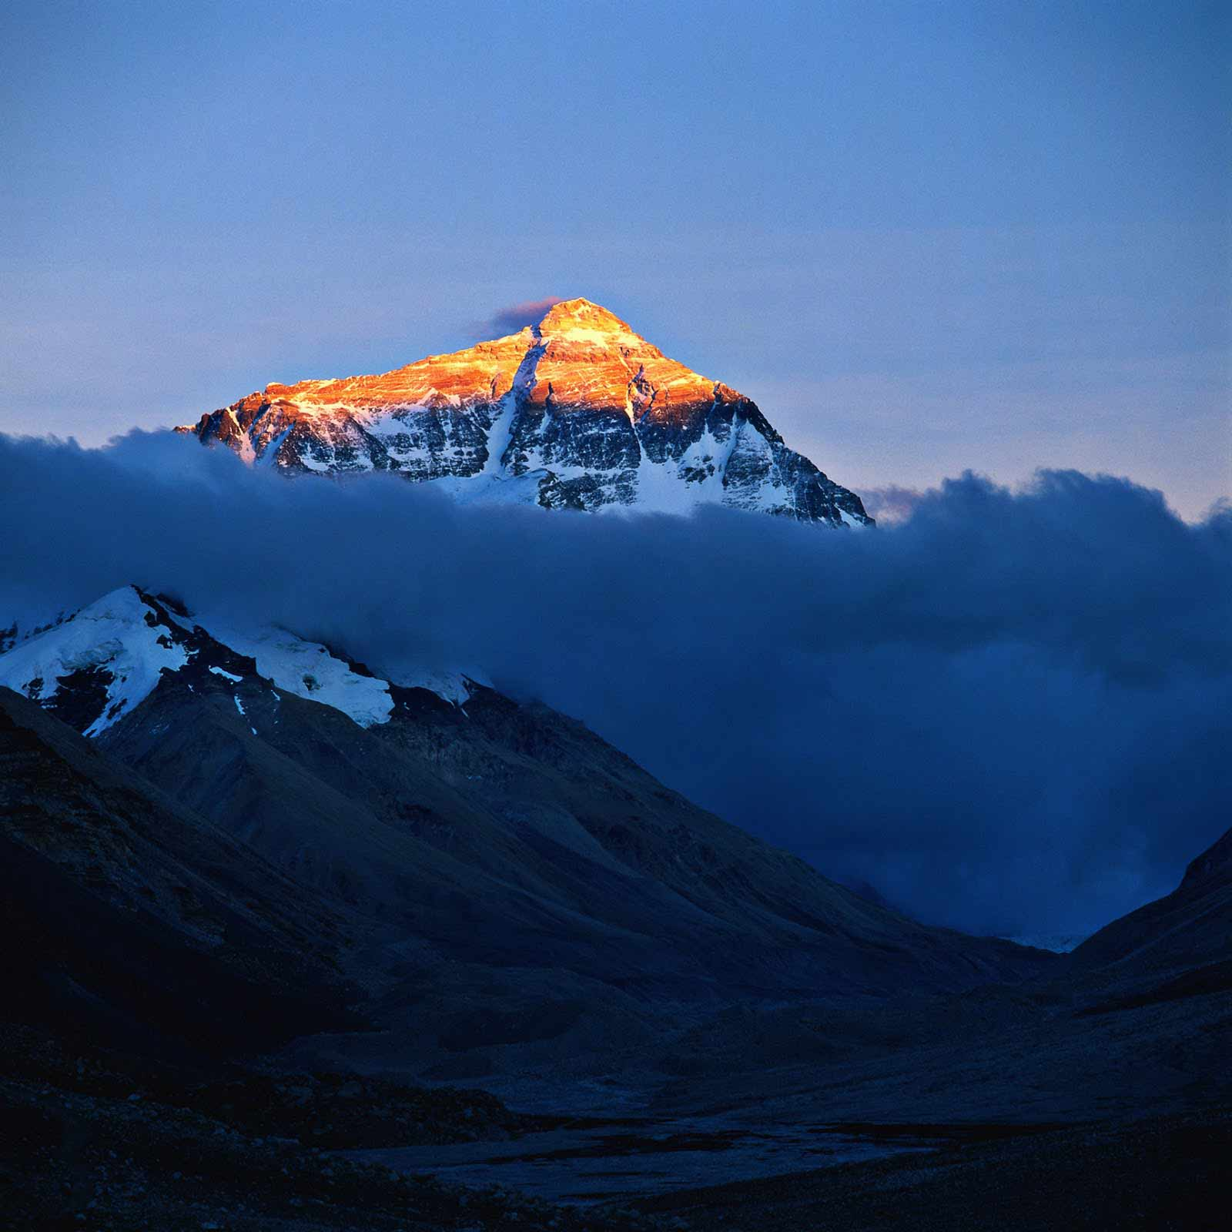
Image Courtesy : 2.bp.blogspot.com/Mount_Everest_(topgold).jpg
The Himalayas are the body and soul of India. In a very special measure, the Himalayas constitute India’s national mountain system. The following few points will bring out the significance of the Himalayan Mountains to India.

1. Climatic Influence:
The Himalayas play a very significant role in influencing the climate of India. By virtue of their high altitude, length and direction, they effectively intercept the summer monsoons coming from the Bay of Bengal and Arabian Sea and cause precipitation in the form of rain or snow.
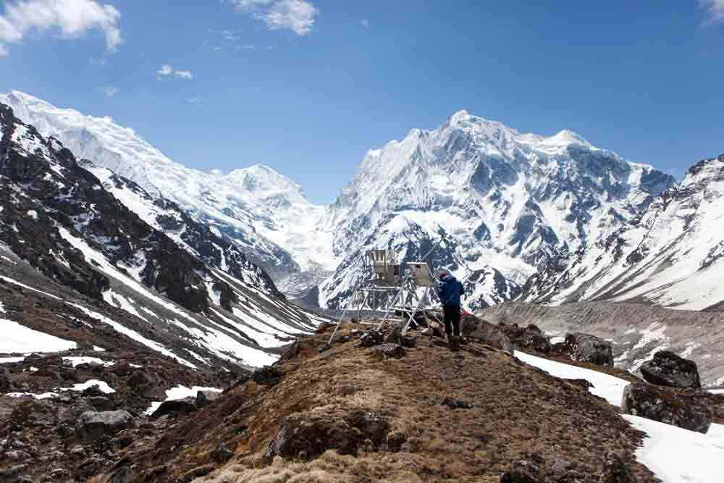
Image Courtesy : climatenewsnetwork.net/wp-content/uploads/19.jpg
Besides, they prevent the cold continental air masses of central Asia from entering into India. Had there been no Himalayas, the whole of India would have been a desert in the absence of precipitation and its winters would have been very severe under the influence of cold airmasses coming from Central Asia. According to the latest meteorological studies, the Himalayas are responsible for splitting the jet stream into two branches and these in turn play an extremely important role in bring monsoons in India.

2. Defence:
The Himalayas have been protecting India from outside invaders since the early times thus serving as a defence barrier. But the Chinese aggression on India in October, 1962 has reduced the defence significance of the Himalayas to a considerable extent. In spite of advancement in modem warfare technology, the defence significance of the Himalayas cannot be ignored altogether.
Image Courtesy : 4.bp.blogspot.com/-

3. Source of Rivers:
Almost all the great rivers of India have their sources in the Himalayan ranges. Abundant rainfall and vast snow-fields as well as large glaciers are the feeding grounds of the mighty rivers of India. Snow melt in summer provides water to these rivers even during dry season and these are perennial rivers. The Himalayan Rivers, along with hundreds of their tributaries, form the very basis of life in the whole of north India.
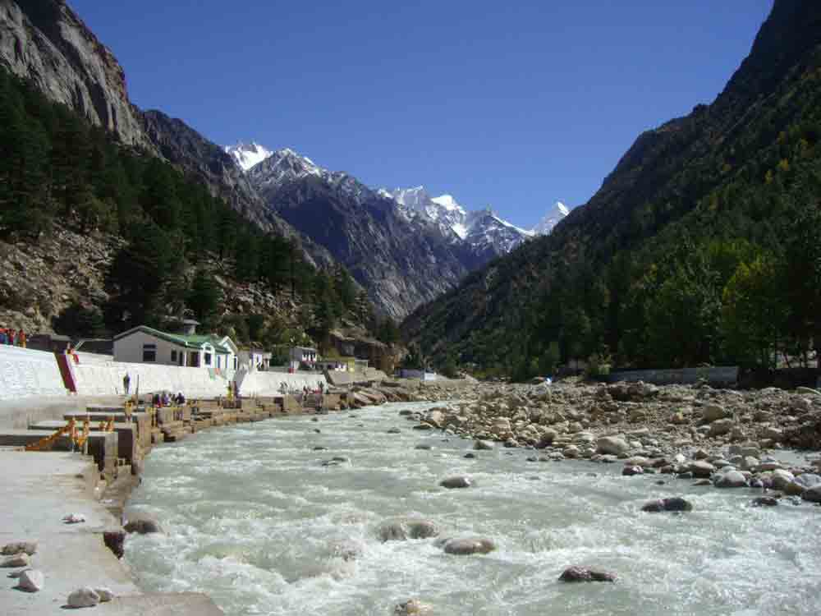
Image Courtesy : upload.wikimedia.org/wikipedia/commons/5/58/Bhagirathi_River_at_Gangotri.JPG

4. Fertile Soil:
The great rivers and their tributaries carry enormous quantities of alluvium while descending from the Himalayas. This is deposited in the Great Plain of North India in the form of fertile soil, making the plain one of the most fertile lands of the world.
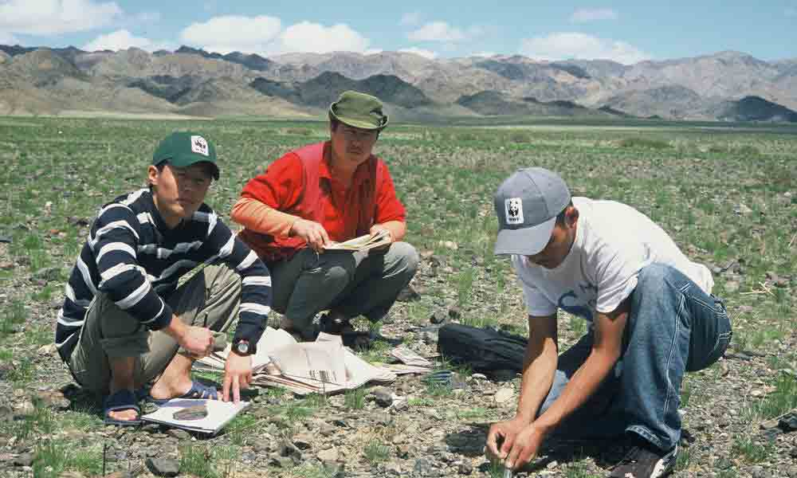
Image Courtesy : assets.worldwildlife.org/photos/1360/images/story_full_width/229986.jpg
It has been estimated that the Ganga and the Indus carry 19 and 10 lakh tonnes of silt, per day respectively and the silt carried by the Brahmaputra is even more. It is, therefore, often said that the great plain of north India is a Gift of the Himalayas.

5. Hydroelectricity:
The Himalayan region offers several sites which can be used for producing hydroelectricity. There are natural waterfalls at certain places while dams can be constructed across rivers at some other places. The vast power potential of the Himalayan Rivers still awaits proper utilisation.
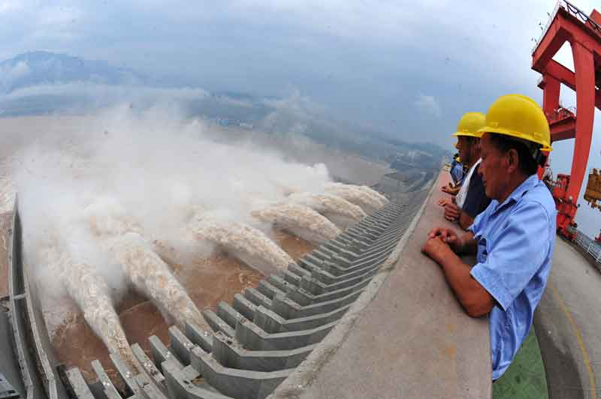
Image Courtesy : apdforum.com/shared/images/2013/03/04/china-india-dam.jpg

6. Forest Wealth:
The Himalayan ranges are very rich in forest resources. In their altitude, the Himalayan ranges show a succession of vegetal cover from the tropical to the Alpine. The Himalayan forests provide fuel wood and a large variety of raw materials for forest based industries. Besides many medicinal plants grow in the Himalayan region. Several patches are covered with grass offering rich pastures for grazing animals.
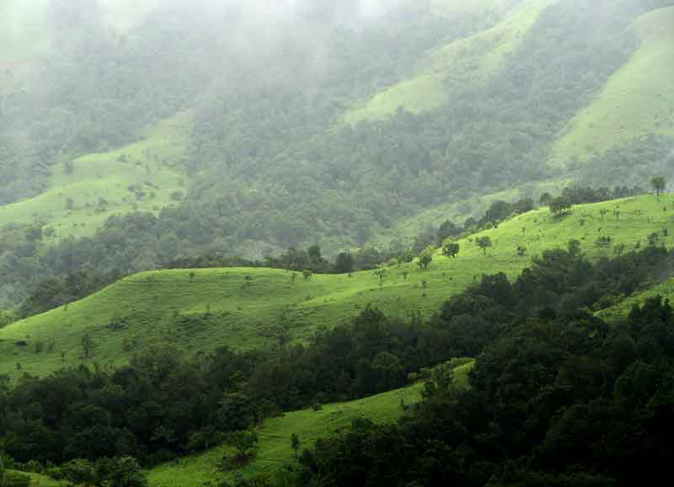
Image Courtesy : upload.wikimedia.org/wikipedia/commons/3/3c/Shola_Grasslands_and_Karnataka.jpg

7. Agriculture:
The Himalayas do not offer extensive flat lands for agriculture but some of the slopes are terraced for cultivation. Rice is the main crop on the terraced slopes. The other crops are wheat, maize, potatoes, tobacco and ginger. Tea is a unique crop which can be grown on the hill slopes only. A wide variety of fruits such as apples, pears, grapes, mulberry, walnut, cherries, peaches, apricot, etc. are also grown in the Himalayan region.
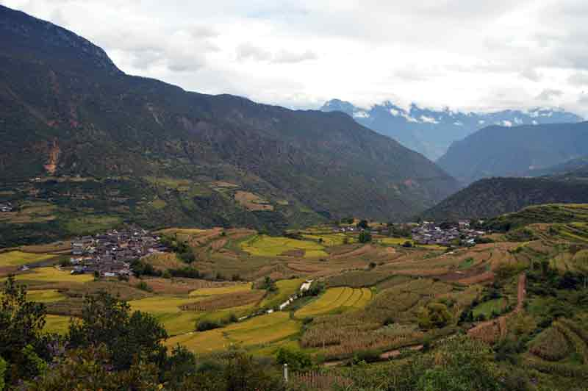
Image Courtesy : goodluckwiththetraffic.files.wordpress.com/2012/10/dsc_0174.jpg

8. Tourism:
By virtue of their scenic beauty and healthy environment, the Himalayan ranges have developed a large number of tourist spots. The hilly areas in the Himalayas offer cool and comfortable climate when the neighbouring plains are reeling under the scorching heat of the summer season.
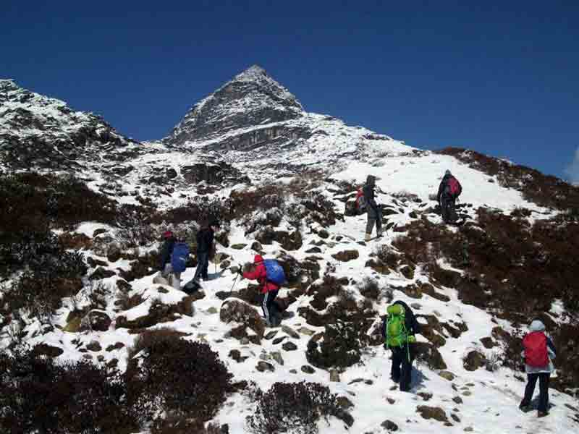
Image Courtesy : bigfoottrek.com/images/indexsmall1.jpg
Millions of tourists from different parts of the country as well as from abroad throng the Himalayan tourist centres to enjoy their natural beauty and to escape from the summer heat of the plains. The increasing popularity of winter sports and the craze to enjoy snowfall has increased the rush of tourists in winters also. Srinagar, Dalhousie, Dharamshala, Chamba, Shimla, Kulu, Manali, Mussoorie, Nainital, Ranikhet, Almora, Darjeeling, Mirik, Gangtok, etc. are important tourist centres in the Himalayas.

9. Pilgrimage:
Apart from places of tourist’s interest, the Himalayas are proud of being studded with sanctified shrines which are considered to be the abodes of the Gods. Large number of pilgrims trek through difficult terrain to pay their reverence to these sacred shrines. Kailas, Amarnath, Badrinath, Kedamath, Vaishnu Devi, Jwalaji, Uttarkashi, Gangotri, Yamunotri, etc. are important places of pilgrimage.
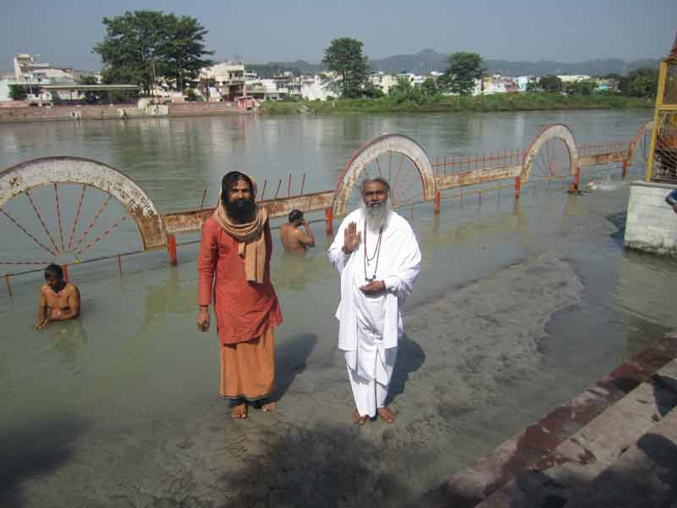
Image Courtesy : atmachaithanya.org/wp-content/uploads/Himalayan-pilgrimage-20121.jpg

10. Minerals:
The Himalayan region contains many valuable minerals. There are vast potentialities of mineral oil in the tertiary rocks. Coal is found in Kashmir. Copper, lead, zinc, nickel, cobalt, antimony, tungsten, gold, silver, limestone, semi-precious and precious stones, gypsum and magnesite are known to occur at more than 100 localities in the Himalayas.
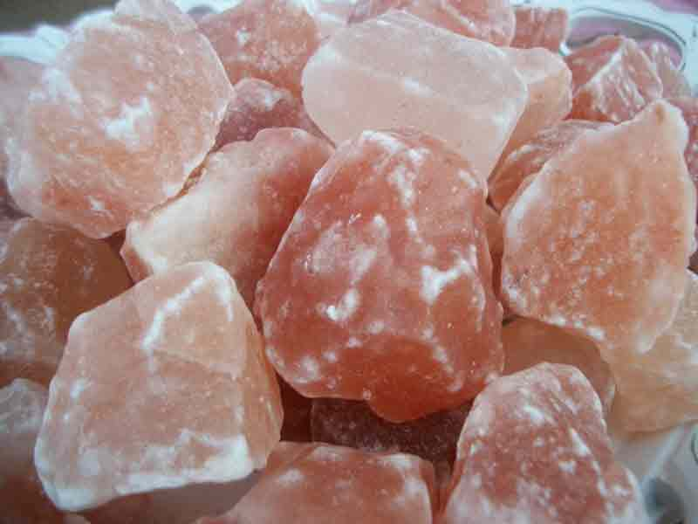
Image Courtesy : alexanderkline.files.wordpress.com/2013/02/il_fullxfull-322519814.jpg
Unfortunately, many of the mineral resources cannot be exploited at the present level of technological advancement due to adverse geographical conditions. Further advancements in modern technology may help in exploiting these resources. So the future possibilities of mineral exploitation in the Himalayas are great.

