Physiography of Himalayas
Physiography of Himalayan Mountain range:
The Himalayan mountains are one of the six physiographic regions of India. The other five physiographic regions of India are:
- Northern Plains
- Indian desert
- Peninsular plateau
- Coastal plain
- Islands
Himalayan and Northeastern mountains/Purvachal come under Himalayas physiographic region.
The following are important geographic characteristics of the Himalayan mountains:
- Himalayas mountains ranges start from Pamir knot in the west and extend up to Puruvachal [ Mizo hills] in the east.
- Geologically: Geologically Himalayas is a young mountain and it is made up of granite sedimentary Rock.
- Structurally: Structurally Himalayas is a type of fold mountain that is made up by convergence of the Indian Plate and Eurasian Plate.
- West to the east stretch of the Himalayas is in an arc form.
- Except for Purvanchal, the Himalayas lie between the Indus River and the Brahmaputra River and have a length of about 2400 km.
- The width of the Himalayas varies from 400 km in Kashmir to 150 km in Arunachal Pradesh.
- Altitude variations are greater in the Eastern half of the Himalayas than in the western half of the Himalayas.
- The northern side of the Himalayan range is called Great Himalayas or Inner Himalayas or Himadri.
- The northern side of the Great Himalayas is called Trans-Himalayas.
- The Trans-Himalayas is made up of the Karakoram range, the Ladakh range, the Zanskar range, and the Kailash range.
- The rivers of the Himalayas are perennial in nature and they make deep gorge and high summit that indicates the youngness of fold mountains.
- Valleys of the Himalayas are part of synclines and Hills are part of anticlines or anti-synclines.

- The whole Himalayas region is tectonic active, hence it is prone to earthquakes and landslides disasters.
- Bright sunshine in heavy snowfall areas leads to excessive snow-melt which causes avalanche disasters in the Himalayan region.

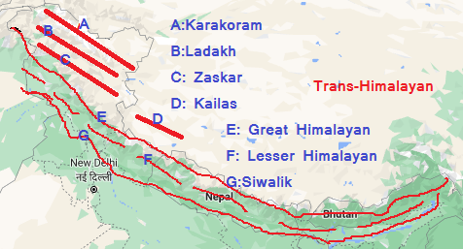

Physiography of the Himalayas can be understood better by dividing it into two parts:
- latitudinal division [north to south]
- Vertical division [west to east]

Latitudinal division or "North to south divisions" of Himalayas:
The greater Himalayan range can be divided into the following four parts from north to south:
- Trans Himalayan range
- The Great Himalayas or Inner Himalayas or Himadri
- The Middle Himalayas or Himachal Himalayas or Lesser Himalaya
- Shiwalik Himalayas or the outer Himalayas
Trans-Himalayas range:
- The Karakoram, Ladakh, Zanskar Range, Kailash Range comes under the Trans-Himalayas. Please refer to the above image for clarity.
- The northernmost part of the Trans-Himalayas is the Karakoram Range.
- Mount K2 or Godwin Austen is the second highest peak in the world after Mount Everest. Mount K2 is on the Karakoram Range.
- Shyok River flows between Karakoram and Ladakh.
- Indus river flows between Ladakh and Zaskar.
- Nanga Parbat (8126 m) is in the Zaskar range.
The Great Himalayas or Inner Himalayas or Himadari:
The great Himalayas is also called the inner Himalayas or Himadri Himalayas.
- It lies immediately south of Trans-Himalayas.
- The average height is about 6100 km above sea level.
- The width of the Great Himalayas is between 120 to 190 km.
- It is the most continuous range and has many snow-bound glaciers.
- Mount Everest, the highest peak in the world is in Great Himalayas.
- The greatest peak of the Mountain range of the world lies in the greater Himalayas.
- Ganga and Yamuna rivers are also originated from Great Himalayas.
- Some important mountain passes in Great Himalayas are Nathu-la, Zoji-La, Shipki-La, etc.
- There is a steep slope on the southern side of the Greater Himalayas than on the Northern side.
Himachal Himalayas or Middle Himalayas or Lesser Himalayas:
- Himachal Himalayas is also called lesser Himalayan or the middle Himalayas or Dhauladhar range
- It lies on the southern side of the Great Himalayas.
- The average width of the Middle Himalayas is about 50 km.
- The altitude of this range is between 1000 and 4500 meters above sea level.
- The famous hill stations in the lesser Himalayas are Shimla, Mussoorie, Nainital, etc.
- The famous Kashmir valley, Kullu valley, and Kangra valley are also located between the Great Himalayas and Lesser Himalayas.
Shiwalik Mountain range:
- It is the southernmost mountain range of the Himalayas.
- Shiwalik mountains range is also called the outer Himalayas.
- The average width of the Shiwalik Mountains range is about 10-50 km.
- The altitudes of Shiwalik mountain vary from 900 to 1100 meters above sea level.
- Duns and Duars are longitudinal valleys lying between the lesser Himalayas and Shiwalik mountain ranges.
- Dehradun and Kotli Dun are important well-known Duns.

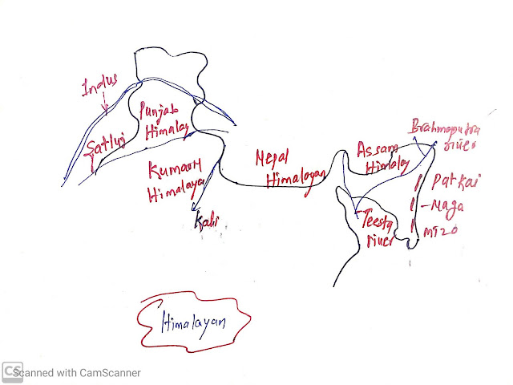

Vertical division or "West to East divisions" of Himalaya:
From west to the east, the Himalayas can be divided into the following parts:
- Punjab Himalayas or Kashmir Himalayas or Northwestern Himalayas
- Kumaon Himalayas
- Nepal Himalayas
- Assam Himalayas
- Puruvachal Himalayas
Punjab Himalayas or Kashmir Himalayas or Northwestern Himalayas;
- The Punjab Himalaya is in the western part of the Himalayas and is situated between the Indus and Sutlej rivers.
- The Karakoram, Ladakh, and Zaskar ranges also come in the Kashmir Himalayas.
- The "Ladakh Cold Desert" is located within the Kashmir Himalayas and is in the northeastern part of the Kashmir Himalayas. It lies between the Karakoram Range and the Himadri Range.
- The Kashmir Valley lies between the Great Himalayas and the Pir Panjal Range [Central Himalayas].
- Famous freshwater lakes like Dal Lake and Wular Lakes are also in the Kashmir Valley.
- Saltwater lakes like Pangong Tso and Tso Moriri are also found in the Kashmir Himalayas.
- The Siachen Glacier and Baltoro Glacier are also found in the Kashmir Himalayas.
- Kashmir Himalaya is also famous for Karewa deposits. "Karewa" are thick deposits of glacial soil and moraine. Zafran or saffron is cultivated on Kareva.
- Sri Nagar is situated on the banks of river Jhelum.
- Important mountain passes in Kashmir Himalayas are Zoji La, Pi-Panjal, Lanak La, Chang La, Banihal La, Aghil Pass, Mintaka Pass, etc.

Kumaon Himalayas;
- It lies between Satluj and Kali rivers.
- Kumaon Himalayas is also called Himachal Himalayas and Uttarakhand Himalayas.
- Some of the Important hills stations such as s Dharamshala, Mussoorie, Shimla, Kausani, Shimla, Mussoorie, Kasauli, Almora, Lansdowne, and Ranikhet are found in the region.
- Duns are longitudinal valleys lying between the lesser Himalayas and Shiwalik mountain ranges.
- Dehradun and Kotli Dun are important well-known Duns.
- Famous pilgrimages such as Gangotri, Yamunotri, Kedarnath, Badrinath, and Hemkund are also located in the Kumaon Himalayas.
- The famous "Valley of Flowers" is located in the region.
- Bara Lacha La, Debra Pass, Rohtang Pass, and Shipki La mountain passes are located in the Himachal Himalayas.
- Lipu Lekh, Mana Pass, Manga Dhura, Niti Pass, and Muling La mountain passes are located in Uttarakhand Himalayas.

Nepal Himalayas;
- It lies between Kali and Teesta rivers.
- Mount Everest, the highest peak in the world is located in the Nepal Himalayas.
Assam Himalayas;
- It lies between Teesta and Dihang rivers.
- Darjiling Himalayas is famous for tea cultivation.
- A variety of orchids are found in the Assam Himalayas.
- Nathu La and Jelep La are mountain Passes located in Sikkim.
- Bom-Di la, Dihand Pass, and Chakan pass are located in Arunachal Pradesh.

Puruvachal Himalayas:
- In the east of Dihang valley, the Himalayan bend in the South and spread along the Eastern boundary between India and Myanmar known as Puruvachal or eastern hill. It is made of sandstone or sedimentary rock.
- Tribal groups practiced the Jhumming cultivation in the region.
- Puruvachal Himalayas is comprised of the followings hills which are arranged from north to South:
  - Patkai Bum
  - Naga hills
  - Manipur hill
  - Mizo hills
  - Barak is an important river in Manipur and Mizoram.
- The unique world-famous, "Loktak lake" which is surrounded by mountains from all sides is in Manipur.
- Mizoram is famous for the "Molasses basin" which is made up of soft unconsolidated deposits.

