Pond Preparation for Freshwater Fish Farming

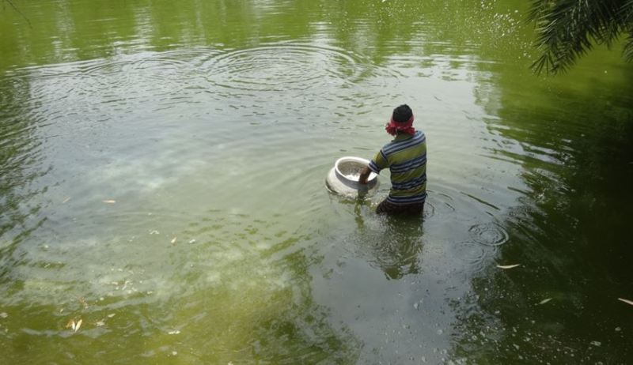A man in the pond
Fish is high-protein source of omega-3 fatty acids, minerals, and other nutrients. The people of India and the rest of the world consume it on a daily basis. The price of fish and fish products grow on a daily basis due to rising of demand. As a result, commercial fish production has become a profitable business.
The freshwater fish farming is one of the most important fish production systems. It refers to the commercial cultivation and the rearing of fish in freshwater systems such as tanks, ponds, and other enclosures for food production. The preparation of the pond prior to the start of fish production is an important phase that has a direct impact on productivity. In this piece, we'll go through the pond preparation procedure and how it might help fish farmers enhance their output.
Importance of pond preparation in fish farming
The most important component of the fish farming business is to prepare a pond in a proper way.
It is not possible to establish or run a fish farming business without the construction of a well-prepared pond. The significance of pond preparation is discussed below.
- Aquatic plants and animals that are detrimental to fish are controlled.
- Cannibalistic and undesirable fish are removed.
- The pond's healthy habitat is protected.
- The optimal pH for fish production is maintained.
- The feed for farmed fish is always available.
Types of ponds used in fish farming
A variety of pond components are used inside the freshwater fish culture unit, including a nursery, raising, production, segregation, and breeding/spawning pool.
The percentage of area covered by these various pond types is listed below:
Nursery pond: 3%
Rearing pond: 11%
Production pond: 60%
Segregation pond: 1%
Breeding pond: 25%
Nature of different ponds
Nursery ponds: Shallow
Rearing ponds: Moderately deep
Production ponds: Moderately deep
Segregation pond: Moderately deep
Breeding ponds: Moderately deep
Water level (for larger production ponds): 2-3 meters

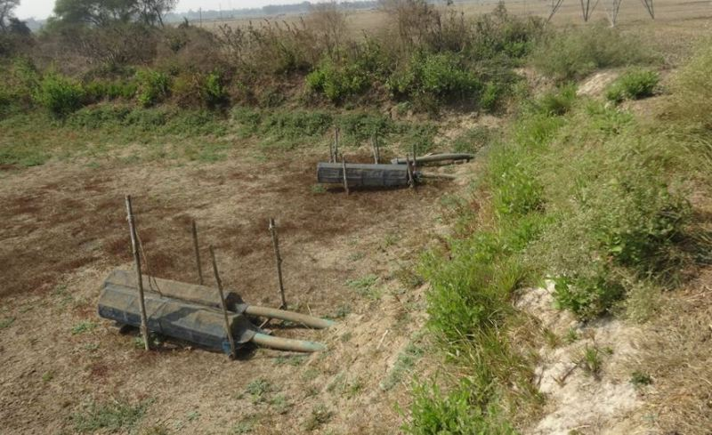Dried Pond
Preparation of pond
- Preliminary or preparation stage
Soil sampling: The soil should be tested before proceeding with the rest of the process. Samples are taken from the pond's and dike's bottoms. In general, the pH and organic matter contents are examined. The pH of the water is significant in determining how much lime will be added later. Soil sample is critical, especially for new ponds.
De-mudding: One of the most important steps in pond preparation is "de-mudding" the pond that we want to prepare. The term "de-mud" refers to the procedure of eliminating mud from the pond that we want to use. The primary goal of de-mudding is to improve its suitability for fish farming. De-mudding can be accomplished simply by removing the mud from the pond, which is the simplest method. Instead of de-mudding, we can deepen our pond, which is the ideal alternative for larger fishes.
Pond drying: The pond's bottom has been dried to eradicate undesired fish species. The earth is dried till it fractures. Drying also ensures that hazardous compounds are oxidized and organic matter is mineralized.
Make the dike of the pond taller: The most typical issue during the rainy season for most ponds is that floods can carry away the pond's fish. If the pond is located near a river or stream, a taller embankment or dike is required. It should be at least 2 to 3 feet higher than the pond's greatest level of water. This may be accomplished extremely easily and automatically while digging or de-mudding. Sand excavated during de-mudding/digging can be used to build taller dikes. Sandbags can also be used to raise the dikes/embankments.
Efficient inlet and outlet system: An efficient inlet and outlet system is critical for the successful operation of the pond system. This is often in the shape of a pipe via which water enters and exits the system. To achieve maximum water flow, the pond's entrance system should be somewhat higher than the output system.
A proper inlet and outlet system prevents the pond from overflowing in the event of heavy rain or a minor flood. This is extremely beneficial to the appropriate management of water quality.
2. Treatment stage
Controlling harmful aquatic plants and animals: Both aquatic weeds and insects are extremely damaging to fish farming ponds, as weeds eat practically all nutrients and restrict the amount of oxygen. Their growth should be efficiently controlled so that they do not cause any problems in the pond.
Removing cannibalistic and unwanted fishes: Removal of cannibalistic and unwanted fishes is very much important step in pond preparation. Shol, gozar, boal, taki, etc. are cannibalistic fish and mola, dhela, chanda, pumpti etc. are unwanted fish. They can be removed by drying the pond or by using poison in the pond. Rotenone powder is the best option for this purpose.
Conditioning the pond: Conditioning is accomplished by spreading a layer of lime or calcium hydroxide over the bottom of the pond for two weeks. It is frequently administered during or after the drying stage of the pond. This reduces soil acidity, facilitates biogeochemical processes, and keeps undesired organisms away.
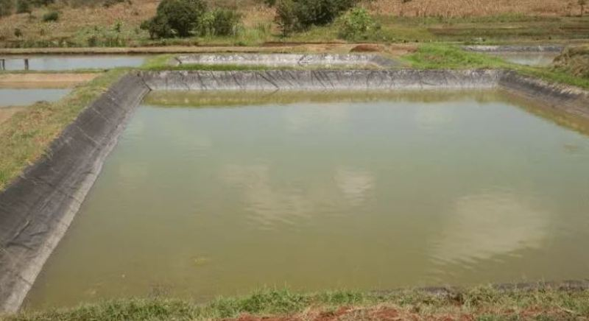Pond
Liming can be done in three different ways:
- By broadcast over a dried pond which includes the dike walls.
- By mixing with water and spraying over the pond and
- By liming the water flowing into the pond.
Manuring: After 15 days of liming, manuring or fertilization is done in order to facilitate the growth of fish food organisms. Manure can be of organic or chemical nature. The application rate of raw cow dung for stocking pond is 2-3 tonnes/ha. The application rate of poultry manure is 5000 kg/ha. Use of chemical fertilizer depends upon the concentration of phosphorus and nitrogen in the soil and varies accordingly. The standard combination of NPK is 18:10:4 for freshwater ponds.
Conclusion
The basic and initial step in freshwater fish farming is fish pond preparation. Pond preparation must be done thoroughly in order to increase the pond's fish productivity. If we start the fish culture procedure without properly preparing the pond bottom, we will have a significant difficulty and low quality produce. In the case of pond preparation, proper management methods are the primary approach for increasing fish productivity. Sustainable measures should always be used to prepare ponds for environmentally friendly fish farming techniques

