Pond Maintenance and Care

If you have a pond in your garden, you have to maintain it every now and then. Pond maintenance will differ from time to time, depending on the season. In spring and in summer a lot of maintenance work has to be done. New plants, feed fish, make and keep the water clear, etc. In autumn and winter it is mainly a question of keeping the pond liveable. Dead plant parts and blown in leaves should be removed before they will be lying on the bottom of your pond during the whole winter. Do not let the pond water freeze over enabling fish and other occupants of the pond to hibernate.

Why Pond Maintenance Is a Mandatory Task
In my experience, maintaining a backyard pond is more challenging than constructing it. When I had finally installed my pond, I thought I could just sit back and enjoy its benefits. I was wrong! I didn't know that it was the beginning of hard maintenance work.
In this article, I will discuss how to maintain a backyard pond and care for the aquatic life. Read on to learn about the best practices for keeping your water feature looking lively throughout the year.

How Often Should I Maintain My Pond?
Pond maintenance should start immediately after the construction is completed. This is one of the most important things I came to learn later. There are many factors that can negatively affect your water feature, and you have to take care of them if you are serious about owning a healthy garden. If you don’t maintain your garden pond, it can become an ugly and unhealthy structure that is not suitable for nurturing aquatic life.

Regular Pond Maintenance Benefits Aquatic Life
Regular pond maintenance is good for the aquatic life. You can enjoy a wonderful ecosystem by just taking proper care of your structure and its aquatics. If you are raising koi or goldfish and growing aquatic plants, you can be sure to enjoy beautiful fish and stunning plants with proper care and maintenance of your water feature.

How to Maintain and Care for a Pond
- Clean your pond regularly.
- Manage the nearby plants.
- Grow water plants.
- Control ice in the winter.
- Control algae growth.
- Maintain pump, filter, lines, and fountains.
- Troubleshoot and repair any leaks.
- Maintain the right water level.
- Maintain the right temperature.
- Make it well-aerated.
- Keep the water chemistry optimum.

1. Clean Your Pond Regularly
Garden ponds accumulate dirt and debris. Leaves are a major threat as they can release toxic gases when decaying, destroying the ecological balance. To keep the reservoir clean, you can use a skimmer net to collect and remove leaves and other light debris.
You also need to remove sludge. You can use a pond vacuum to scoop the mud from the bottom, but you need to leave a little of it to support the growth of algae.
Only a few of the many pond vacuums developed can help clean your pond bottom effectively. I use the OASE PondoVac Vacuum Cleaner which is powerful enough to remove sludge, debris and decaying organic matter. With different nozzle head options, this equipment can clean through gravel, stoney, earthy and even flat surfaces.
One more thing I like about this pond vacuum is its alternating suction and discharge system, which makes the whole sludge removal process quite easy. Other interesting features include clear extension tube for easy visual inspection and debris collection bag. I would recommend this equipment to people who have been finding it difficult to clean their water features.
If you want to do a full cleaning, drain all the water first using a pump or container then secure your aquatics in another reservoir. Next, scoop up the sludge and clean the bottom completely. You can also clean the liner and edging materials - a task that can be performed with a brush.
After you have completed cleaning, return some of the sludge and refill the pond with fresh water. Finally, return your aquatics safely to the reservoir. Note: It is advisable to perform a full cleaning in early spring when the aquatics are less active.

2. Manage the Nearby Plants
If you have trees in your garden, your water feature can be affected negatively by falling leaves. You can prevent this problem by using a trap net. Install the net over the structure and use a filter mat below it to trap the smaller debris. You can secure the net and mat with rocks or bricks. When there is a heavy leaf fall, you need to empty the net regularly to prevent it and its content from falling into the water. The net and mat have another benefit of protecting your aquatic animals from predators.
If you have trees hanging over the structure, prune them using a garden shear or any other suitable tool. The shading trees prevent light from reaching the aquatic plants, inhibiting them from getting full photosynthesis.

3. Grow Water Plants
The best time to introduce new plants is in the early summer when the water is warm and capable of supporting rapid plant growth. Some categories of plants that you should consider growing include oxygenators, lilies, marginals, floaters, and marshes.
You can boost the growth of the plants with a suitable fertilizer which you can apply every five weeks. Since some aquatic animals use the plants as food, keep them as healthy as possible. Do not use toxic fertilizers or inorganic pesticides.
Keep thinning or culling the plants and ensure their leaves do not cover the whole surface of the water. You can use a garden rake to remove the excess aquatics. Some of the aquatic plants may die as a result of freezing or after the end of their lifespan. If you notice some dead plants, remove them immediately to prevent the disruption of the water chemistry or formation of toxins.
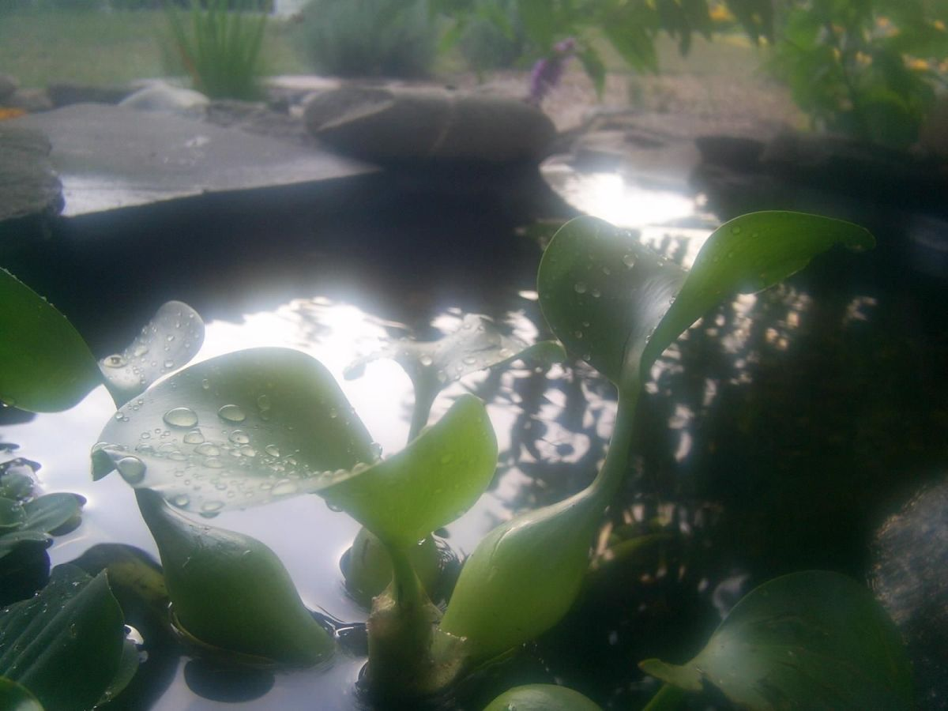
some aquatic plants in a garden pond

4. Control Ice in Winter
Ice is a common problem in winter. If your pond's water surface freezes, the water below the ice starts to get limited oxygen and develops very low temperatures which put your aquatics in danger.
You can prevent freezing by floating a ball or de-icer on the surface. You can also prevent the problem by installing a heater. If you already have ice on the surface, you can use a hot pan to melt it, but do not use force to break it as this can harm the aquatic life.
If you cannot do away with the ice, you can control its effects by floating wood on the surface. The wood will absorb the ice pressure and therefore protect the structure from damage. It is recommended to add an air hole through the ice to improve the effectiveness of the wood.
Moreover, you can construct a cover above the structure to insulate it from cold air. Use PVC materials or lumber to construct the cover, and your chosen material should be clear or transparent to allow light into the water when you install the cover.
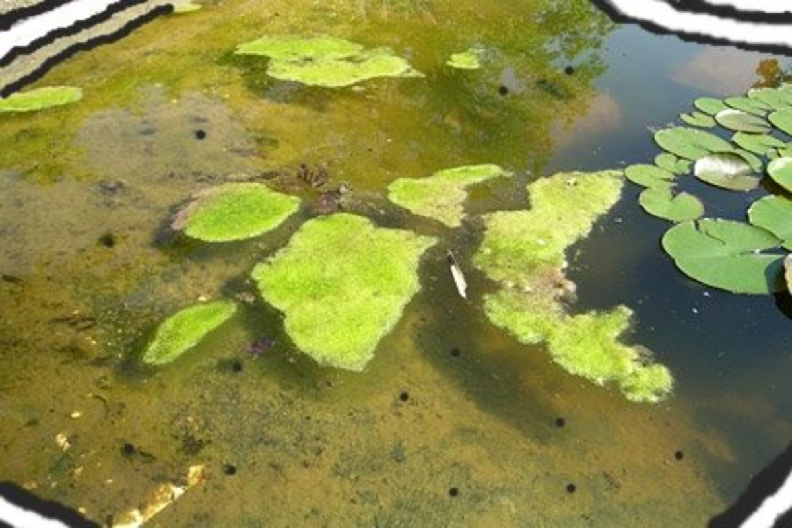
A garden pond with excess algae

5. Control Algae Growth
Algae are beneficial in a garden pond, but they can be a big problem when they are allowed to grow excessively. These non-flowering plants are a good source of food for the aquatic animals, so it is recommended not to remove all of them. When it comes to controlling these micro-plants, you can use both natural and artificial methods.
One natural way is to grow aquatic plants that can compete with the micro-plants for nutrients and other resources. Introduce plants that use large quantities of nutrients, such as lettuce and hyacinth. You can also introduce cover plants like lilies which minimize the amount of light reaching the algae.
On the side of the artificial methods, you can use a tool like a rake to physically remove the non-flowering plants. This involves detaching the colonies from the surfaces and disposing them away. Another artificial method is to use algaecides or dye. The latter turns the water surface black, reducing the amount of light reaching the algae. In addition, you can use an ultraviolet water purifier or sterilizer to control the micro-plants.
From my own experience, algaecides are the most effective method of controlling algae. But not all of these chemical substances are capable of eliminating the micro-plants. I use the API Pond Algaefix which has proved to be effective in keeping my water feature clean and clear. It controls many types of algae, including the green, string, single-cell and hair algae.
The best thing about this algaecide is that it kills existing algae and prevents additional algae blooms. Another great thing about the control substance is that it is safe for aquatic plants and animals, including fish. If algae has become a menace in your water garden, I would encourage you to use this algaecide.

6. Maintain the Pump, Filter, Lines, and Fountains
These parts are commonly found in large or complex ponds, and are prone to clogs which can be caused by debris. During the warm seasons, the pumps and filters are made to run for many hours, something which makes them vulnerable to malfunctions.
If your pump or mechanical filter gets clogged, disconnect it and flush out the debris. Concerning the biological filter, you need to clean it partially to avoid killing all bacteria which are useful in breaking down ammonia and other compounds.
The lines and fountains suffer from limescale and algae bloom. To maintain these parts, you can use cleaning chemicals to remove the limescale and algaecides to kill the algae.

7. Troubleshoot and Repair Any Leaks
If your pond's water level starts to drop rapidly, you should suspect a leaking problem. If the surrounding ground is wet and you didn't pour water on it, then you can confirm that your pond is leaking.
To repair the leak, you need first to drain the water. It is important to follow the right draining procedure (see the cleaning sub-topic above). The next thing is to repair the structure with the right materials. Some commonly used repair materials are soil, concrete, and rocks.
If the leakage is happening in the accessories, you should expect it to be caused by holes, cracks, or disconnections, which you need to repair accordingly. If there is a repair work that you cannot do on your own, you can get help from a pond repair professional.

8. Maintain the Right Water Level
The water level of a pond drops quickly in hot weather (common in summer), and this can make the aquatic organisms lack enough oxygen. If you notice a reduction in the water level, you need to top up the pond with clean water. You should avoid using tap water as it contains a lot of solutes and encourages excessive growth of algae.
Use a garden hose to top up, but you can also install a water supply system consisting of a fill valve and filter. You need to keep three-quarters of the structure full throughout the year. In extremely hot months, you can refill on a weekly basis.

9. Maintain the Right Temperature
During the winter season, ice can form on the pond surface lowering the water temperature. If this happens on your water feature, you can use a heating system to create an optimum temperature.
In summer, the water can heat up, affecting some of the aquatics negatively. When the water temperature becomes too high, you can sprinkle or spray cold water to bring the temperature to the optimum levels.

10. Make Your Pond Well-Aerated
Well-aeration water is quite beneficial to the aquatic life. It allows the aquatics to get enough oxygen, boosting a healthier growth in the plants and animals. It also reduces algae growth and odor formation, facilitating a pleasant water garden.
You can introduce oxygenating plants to improve oxygen levels. You can also use waterfalls, bubblers, or fountains to improve air movement in and out of the water. In addition, you can use an air pump to maximize aeration in summer which is associated with diminished air levels in reservoirs.

11. Keep the Water Chemistry Optimum
A number of things can alter the water chemistry. One thing that is well known to interfere with water chemistry is chlorine, which can kill the aquatic organisms. The water chemistry can also be altered by decaying plant remains which release harmful products and add unnecessary organic matter to the water. To detect any changes in the water chemistry, you need to carry out tests every now and then.
If you detect any changes, you can use alkaline solutions and detoxifiers, which control acidic and toxic conditions respectively. To prevent these changes, you need to keep your pond clean, something which reduces the build-up of waste. If you are keeping fish, you need to avoid supplying them with excess food to prevent cases of decaying food remains. In addition, you need to edge your structure to control run-off water which can bring in harmful chemicals.

