What are insects classification and characterise?

Insect Classification
Scientific Classification-
Kingdom: Animalia
Phylum: Arthropoda
Subphylum: Hexapoda
Class: Insecta
Insect scientific name: Insecta

What is an Insect?
Insect Definition-Insects are invertebrate species of the Insecta class, within the Phylum Arthropoda, the largest and (on land) most widely distributed taxon. Insects, with about 925,000 species described, form the most numerous and diverse group of animals. Indeed, more than half (approximately 57 percent) of all animal species known are insects, and some authorities claim that less than 10 percent of living insect species have actually been described and named.

Types of insects

Moths and butterflies

Ants, wasps, bees and sawflies

Grasshoppers, crickets, locusts and earwigs

Flies, dragonflies and lacewings

Bugs, cicadas & beetles

Cockroaches, termites, mantids and stick insects

Insect, (class Insecta or Hexapoda), any member of the largest class of the phylum Arthropoda, which is itself the largest of the animal phyla. Insects have segmented bodies, jointed legs, and external skeletons (exoskeletons). Insects are distinguished from other arthropods by their body, which is divided into three major regions: (1) the head, which bears the mouthparts, eyes, and a pair of antennae, (2) the three-segmented thorax, which usually has three pairs of legs (hence “Hexapoda”) in adults and usually one or two pairs of wings, and (3) the many-segmented abdomen, which contains the digestive, excretory, and reproductive organs.

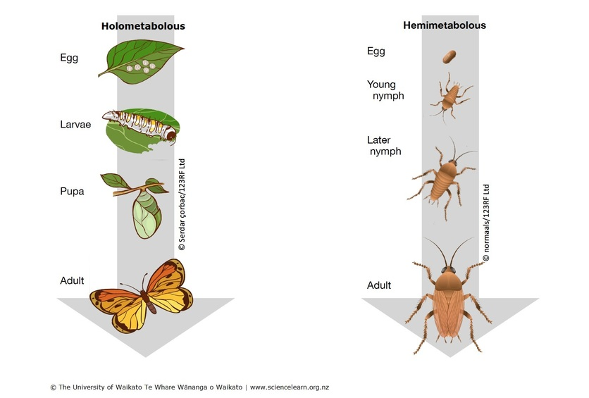

In numbers of species and individuals and in adaptability and wide distribution, insects are perhaps the most eminently successful group of all animals. They dominate the present-day land fauna with about 1 million described species. This represents about three-fourths of all described animal species. Entomologists estimate the actual number of living insect species could be as high as 5 million to 10 million. The orders that contain the greatest numbers of species are Coleoptera (beetles), Lepidoptera (butterflies and moths), Hymenoptera (ants, bees, wasps), and Diptera (true flies).

1. Holeopteran, (order Coleoptera), any member of the insect order Coleoptera, consisting of the beetles and weevils. It is the largest order of insects, representing about 40 percent of the known insect species. Among the over 360,000 species of Coleoptera are many of the largest and most conspicuous insects, some of which also have brilliant metallic colours, showy patterns, or striking form. Beetles can usually be recognized by their two pairs of wings; the front pair is modified into horny covers (elytra) that hide the rear pair and most of the abdomen and usually meet down the back in a straight line. Coleoptera occur in nearly all climates. They may be divided into four groups: the first three, the Archostemata, the Adephaga, and the Myxophaga, contain relatively few families; the majority of beetles are placed in the fourth group, the Polyphaga.
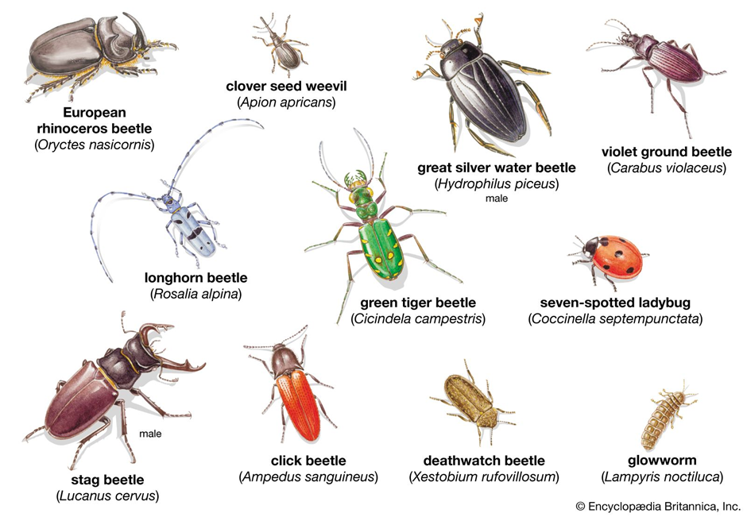

2. lepidopteran, (order Lepidoptera), any of about 180,000 species of butterflies, moths, and skippers. This order of insects is second in size only to Coleoptera, the beetles.
Because of their day-flying habits and bright colours, the butterflies are more familiar than the chiefly night-flying and dull-coloured moths, but the latter are far more varied and abundant. The skippers are a worldwide group intermediate between butterflies and moths. With the exception of a few moths, all adult lepidopterans have two pairs of wings. The name Lepidoptera is derived from the Greek, meaning “scaly winged,” and refers to the characteristic covering of microscopic dustlike scales on the wings.
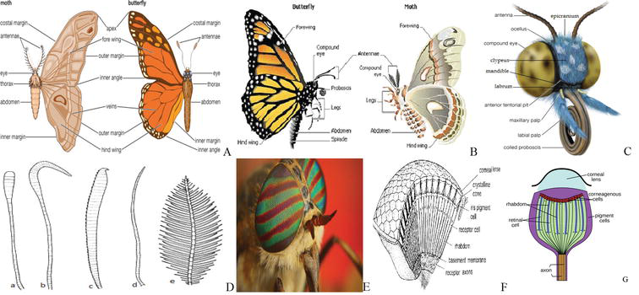
3. dipteran, (order Diptera), any member of an order of insects containing the two-winged or so-called true flies. Although many winged insects are commonly called flies, the name is strictly applicable only to members of Diptera. One of the largest insect orders, it numbers more than 125,000 species that are relatively small, with soft bodies.

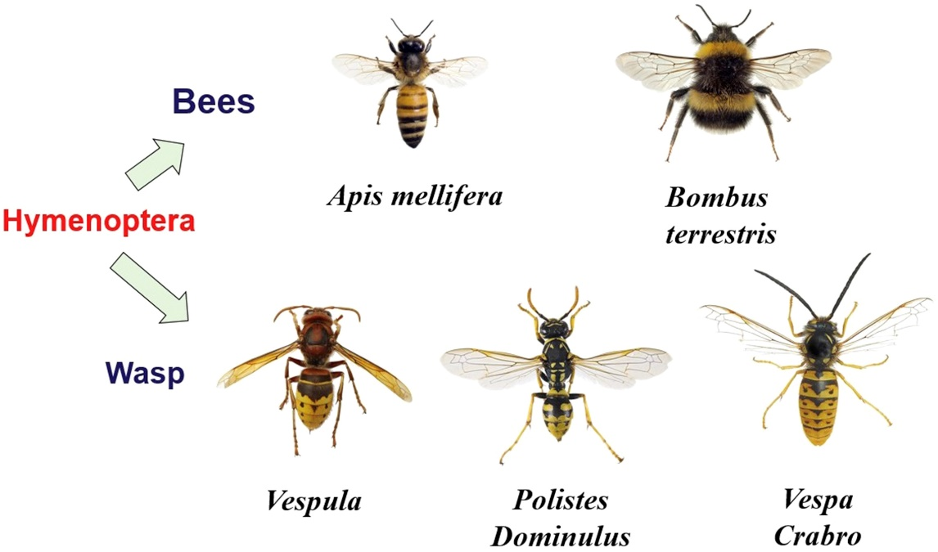

4. hymenopteran, (order Hymenoptera), any member of the third largest—and perhaps the most beneficial to humans—of all insect orders. More than 115,000 species have been described, including ants, bees, ichneumons, chalcids, sawflies, wasps, and lesser-known types. Except in the polar regions, they are abundant in most habitats, particularly in tropical and subtropical regions.

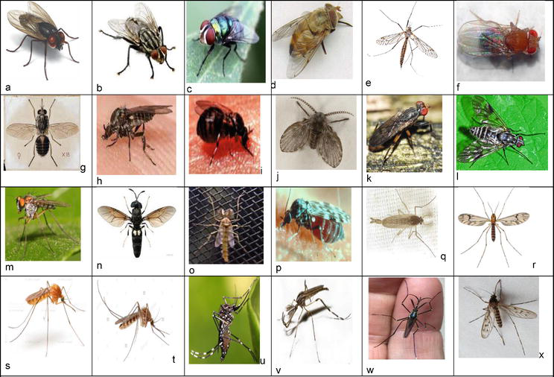

Appearance of insect
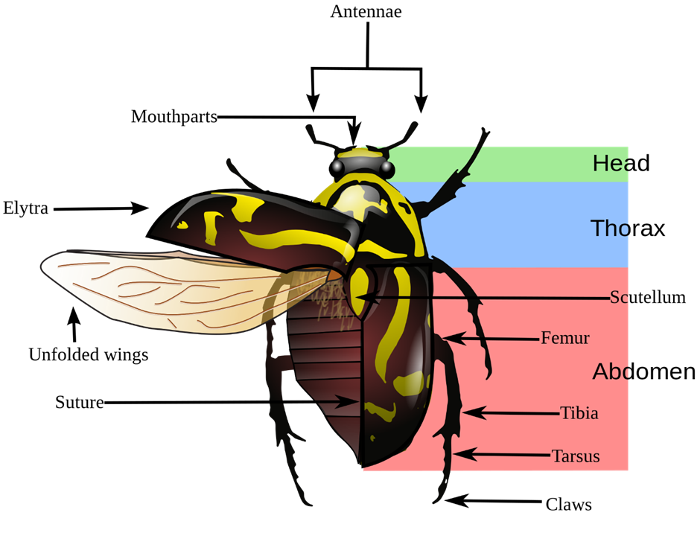

The majority of insects are small, usually less than 6 mm (0.2 inch) long, although the range in size is wide. Some of the feather-winged beetles and parasitic wasps are almost microscopic, while some tropical forms such as the hercules beetles, African goliath beetles, certain Australian stick insects, and the wingspan of the hercules moth can be as large as 27 cm (10.6 inches).
In both in nature and human culture, insects play a crucial role. They are a crucial link in food networks, being widespread and numerous. Also, they are invaluable as pollinators and in nutrient recycling. As far as humans are concerned, insects (producing silk, honey, shellac and pollinating crops) are both economically beneficial and have destructive implications as agricultural pests and disease bearers. Historically, as symbols in religions, insects were very common, whether in myths related to the creation of the universe or the scarab that served as the most important religious symbol of ancient Egypt.

Characteristics of Insects
Insects have jointed appendages as arthropods (arthropod means "jointed foot"), an exoskeleton (hard, external cover), segmented body, ventral nervous system, digestive system, open circulatory system, and advanced sensory receptors. The word "jointed appendages" applies to both antennae and legs.
Insects are characterized by having three pairs of jointed legs from other arthropods; an abdomen that is divided into 11 segments and lacks any legs or wings; and a body split into three sections with one pair of antennae on the head (head, thorax, and abdomen). Sometimes, insects also have one or two wing pairs.
True insects (that is, species listed in the Insecta Class) are also partially differentiated by having ectognathous or exposed mouthparts from all other arthropods. This is the reason why they are often referred to as Ectognatha, synonymous with Insecta. As adults, most animals, though by no means all, have wings. Terrestrial arthropods, such as centipedes, millipedes, scorpions, and spiders, are often confused with insects because both have identical body plans, sharing a joint exoskeleton (as do all arthropods).

Different Types of Insects
While only a limited number of species have adapted to life in the open ocean, where crustaceans tend to predominate, they are present in almost all habitats on the earth. Insects are capable of adjusting to extreme temperatures and can also be found on glaciers in the highest mountains of the world, the South Pole, and in hot springs.
Insects range from less than a millimeter in size to over 18 centimeters in length (some walking sticks).
Types of Insects- The most numerous insects, with over 400,000 species described, are the beetles. There are also some 170,000 species of butterfly and moth, 120,000 species of fly, 82,000 species of true bug, 110,000 species of bee and ant, 5,000 species of dragonfly, 2,000 species of praying mantis, and 20,000 species of grasshopper. Thousands of new insect species are described each year, however, and estimates vary from two to thirty million of the total number of existing species, including those not yet known to science, with most authorities preferring a figure halfway between these extremes.

Parts of an Insect

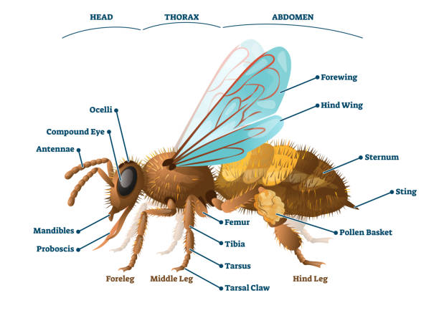
Insects have segmented bodies covered by an exoskeleton, often made of chitin, a rough outer coating. The body is divided into an abdomen, a thorax, and a head. A pair of sensory antennae, a pair of compound eyes and a mouth are supported by the head. The thorax has six legs and wings (one pair per segment) (if present in the species). There are excretory and reproductive structures in the abdomen.
The nervous system of the insect can be separated into a brain and a cord of the ventral nerve. The brain represents this in its structure, comprising six pairs of ganglia, since the head capsule consists of six anterior body segments. The first three pairs are fused into the brain, while a structure called the subesophageal ganglion is fused into the three following pairs. There is one ganglion on either side of the thorax pair, with one pair of ganglia in each thoracic branch. This arrangement is also present in the abdomen, but in the first eight segments only, there is one pair of ganglia. In other words, there are three thoracic ganglia and eight paired abdominal ganglia.
While this definition reflects a "idealized" insect, many insect species have a lower number of ganglia in fact. This is due to the gradual loss of ganglia or the fusion of some of the ganglions in the abdomen and/or the fusion of those in the thorax. Some cockroaches, for instance, have only six ganglia in the abdomen, while the Vespa crabro wasp has further reduced the number, with only two in the thorax and three in the abdomen. Some insects have fused all the body ganglions into one large thoracic ganglion, such as the well-known housefly.
Insects have a complete system of digestion. That is, in contrast to the imperfect digestive systems found in many simpler invertebrates, their digestive system consists essentially of a tube that runs from the mouth to the anus. The excretory system consists of Malpighian tubules for osmoregulation for the removal of nitrogenous waste and the hindgut. Insects are capable of reabsorbing water along with potassium and sodium ions at the end of the hindgut. Therefore, insects typically do not excrete water in their urine, helping to store the body's water. This re-absorption process helps them to withstand dry, hot conditions.
There are two pairs of wings found on the second and third thoracic segments in most insects. The only invertebrate community that has established flight is insects, and this has played an important role in their success. Winged insects, and their wingless relatives, make up the Pterygota subclass. Insect flight, depending heavily on turbulent atmospheric effects, is not very well known. Flight appears to rely on direct flight muscles, which operate upon the structure of the wing, in more primitive flying insects. In general, more advanced flyers that comprise the Neoptera have wings that can be folded over their back, holding them out of the way when not in use. The wings are operated primarily by indirect flight muscles in these insects, which move the wings by stressing the thorax wall. When stretched without nervous impulses, these muscles are able to contract, allowing the wings to beat much more rapidly than would otherwise be possible.
The outer skeleton of insects, called the cuticle, consists of two layers: the epicuticle, which is a thin and waxy, water-resistant, outer layer and contains no chitin, and the procuticle, another layer under it. The chitinous procuticle is much thicker than the epicuticle, and it can be broken into two new layers. The first one is called the exocuticle, and the endocuticle is the second and deepest one. Numerous layers are constructed of the very tough and flexible endocument, made of chitin fibers and proteins crossing each other in a sandwich pattern.

Respiration in Insects

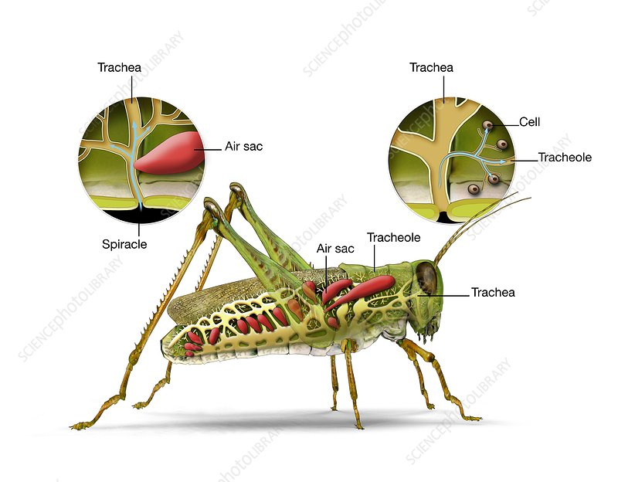
In order to distribute oxygen through their bodies, insects use tracheal respiration. Openings called spiracles on the surface of the body contribute to the tubular tracheal system. Through this method of branching trachea, air enters internal tissues. There are no more than a pair of spiracles per segment and never more than two pairs of thoracic spiracles (mesothorax and metathorax) or more than eight pairs of thoracic spiracles (mesothorax and metathorax) on the abdomen (the first eight segments). The number of spiracles has been decreased by several larger insects; all the spiracles on their abdomen have been lost by the hoverflies. There is a pressure cap that the walls of the tracheal tubes can endure without collapsing, even though the bands of chitin are stiffened, which is one of the reasons why the insects are relatively thin.
Equipped with muscle-controlled valves, the spiracles allow the insects to open and close them. They can prevent drowning in water by closing them, as well as prevent moisture from escaping from their bodies by opening them only when fresh air is required. The spiracles are also partly shut when there is little operation. The spiracles have hair that cleans the particles away in order to stop dust and other unwanted small particles from entering their trachea system when inhaling.
Some insect species, such as Chironomidae members, generally referred to as 'blood worms,' produce true respiratory pigments such as hemoglobin during their larval stage. As their body can consume oxygen directly from the water, the tracheae are often reduced here, allowing them to survive in the bottom mud where oxygen levels are low. In water bugs, three pairs of spiracles are covered by a pressure sensitive membrane. These act in much the same way as the inner ear of the human being, and make it possible to feel their place in the water.
There is also a distinction between the last abdominal spiracle and the associated caterpillar trachea in the Lepidoptera field. The eighth section trachea is modified into what can be considered a pulmonary trachea, which is adapted to the exchange of hemocyte gas. Inside the tracheole cell basement membrane, small tracheoles from this trachea end in knots. Because they do not supply any cellular tissue, they seem most likely to supply oxygen to the hemocytes. To make a loud hissing sound, the Madagascar hissing cockroach expels air from some spiracles.

Reproduction in Insects
Polyembryony is also found in some insects. In fact, a single fertilized egg from polyembryonic parasitic wasps can break into literally thousands of distinct embryos.
The adult stage of an insect with complete metamorphosis is a butterfly. Anartia amathea is this genus.
Some insects hatch from eggs, some are ovoviviparous or viviparous, and as they evolve and develop in size, both undergo a series of molts. The exoskeleton needs this way of growth. In order to increase in size, molting is a mechanism by which the organism escapes the confines of the exoskeleton, then produces a new outer covering.
Young insects, called nymphs, are essentially similar in shape to adults (such as grasshoppers and termites) in certain species of insects, but wings do not develop until the adult stage, and reproductive organs are undeveloped. This is known as incomplete metamorphosis, which includes the fetus, nymph, and adult stages.
The Endopterygota, which comprises many of the most popular insect classes, is characterized by complete metamorphosis. An egg hatches to produce a larva in these species that is typically worm-like in shape, including eruciform (caterpillar-like), scarabaeiform (grublike), campodeiform (elongated, flattened, and active), elateriform (wireworm-like), and vermiform (maggot-like). The larva develops and finally, in some species, becomes a pupa, a stage enclosed inside a cocoon (or chrysalis). Three types of pupae are available: obtect, exarate, and coarctate. The insect undergoes major changes in shape in the pupal stage to emerge as an adult (or imago).
Butterflies are an instance of an insect undergoing absolute metamorphosis. Metamorphosis encourages longevity in that there is no competition between the adult and the larva for resources and helps to survive, since the pupal stage also occurs during harsh environments, such as winter.
Haplodiploidy, polymorphism, paedomorphosis, sexual dimorphism, parthenogenesis, and hermaphroditism are other development features found in different insects.
Robber Fly Image: Bruce Hulbert
© Bruce Hulbert

Insect are successful and important
The insects have proved to be the most successful arthropods. There are far more species in the class Insecta than in any other group of animals. These amazingly diverse animals have conquered all the environments on earth except for the frozen polar environments at the highest altitudes and in the immediate vicinity of active volcanoes.
Insects are the only invertebrates (animals without backbones) with wings. Much of their success results from their ability to fly and colonise new habitats. The study of insects is called entomology and entomologists are scientists who study insects.
Insects play a very important role in the web of life, in every environment. Some of their jobs include pollinating flowering plants, being a source of food for insectivorous animals and assisting in the decomposition of plants and animals.
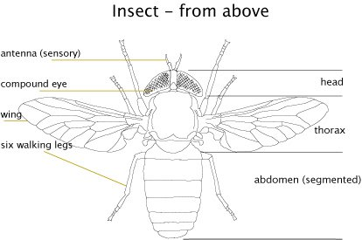
t Diagram
Image: Design Unit
© Australian Museum

The insect body
It is very difficult to provide a simple answer to the question: What external features characterise an insect? This is because the class Insecta is full of exceptions. It is not easy to produce a typical body plan for what most insects look like, but there are some very general features that most insects possess.

Insect features
- The insect body is divided into three main parts, the head, thorax and abdomen.
- Insects have no internal skeleton, instead they are covered in an external shell (exoskeleton) that protects their soft internal organs.
- No insect has more than three pairs of legs, except for some immature forms such as caterpillars that have prolegs. These are appendages that serve the purpose of legs.
- The typical insect mouth has a pair of lower jaws (maxillae) and upper jaws (mandibles) which are designed to bite. There are many variations to this structure, as many moths and butterflies have tubular sucking mouthparts, many bugs and other blood-sucking insects have sucking stabbing mouthparts and some adult insects simply don't have functional mouthparts.
- Insects have one pair of antennae located on the head
- Most insects have one or two pairs of wings although some insects such as lice, fleas, bristletails and silverfish are completely wingless.
Together these features can help us distinguish insects from other arthropods.

Insect evolution
Insects are an ancient group of animals. The first insects probably appeared before the Devonian period (400 - 360 million years ago) and by the Carboniferous period (360 - 285 million years ago) had taken to the air.
Adaptation to flight proved a highly successful strategy and during the Permian period (285 - 245 million years ago) insects achieved their greatest diversity. No other arthropod group has achieved flight. By the Permian, the basic physical structure of many of the modern orders of insects had evolved.
The more recently evolved Hymenoptera (ants, bees, wasps and sawflies) and Lepidoptera (butterflies and moths) appear as fossils in the Jurassic period (210 - 145 million years ago). The Mantodea (praying mantids) appeared in Eocene period in fossilised amber (60 - 35 million years ago).

