Freshwater Microbial communities
The microbial community in freshwater is as diverse as any other ecosystem found on earth. These microbes have found a way to take advantage of the different resources provided from lake habitats oppose to terrestrial soil habitats microbes are usually thought to live. The main players are Proteobacteria, Cyanobacteria, Actinobacteria, and Bacteroidestes. All of these different microbes contribute to important processes carried out in freshwater.
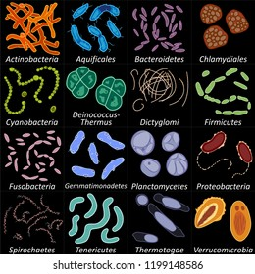

Proteobacteria
This is the most abundant and commonly found group of microbes in freshwater lakes. Taxa include Rickettsia prowazekii, Coxiella burnetti, and Wolinella succinogenes. Proteobacteria is broken up into alpha-, beta-, delta-, and gamma proteobacteria, each with their own distinct characteristics (Yannarell 2009).
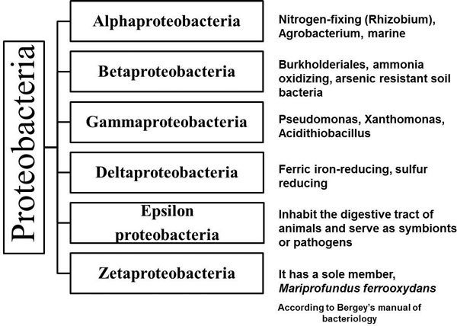

Alpha/Gamma proteobacteria
Alphaproteobacteria and Gammaproteobacteria are mostly commonly found in marine habitats, but still can be found in freshwater water columns. They tend to be phototrophic and contribute to increasing the amount of dissolved oxygen in a lake. Taxa include Acetobacter and Acinetobacter for Alphaproteobacteria and Gammaproteobacteria respectively.

Betaproteobacteria
Betaproteobacteria are most common of the proteobacteria in lakes. They consist of Chemolithotrophes and phototrophs, who in some places makes up 60% of the bacterioplankton. They also play an important role in nitrogen fixation and oxidation of ammonium (Wetzel 2000). Taxa include Alcaligenes and Nitrosomonas

Deltaproteobacteria
Deltaproteobacteria tend to live in anaerobic conditions such as the bottom of lakes or in sediment and they commonly reduce sulfur as a source of energy. Taxa include Desulfovibrio and Geobacter.

Cyanobacteria
Cyanobacteria are bacteria that carry out photosynthesis. They tend to be the dominant bacterial phototrophs in open parts of a lake and are important in the carbon cycle, but also the nitrogen cycle because some are capable of nitrogen fixation.
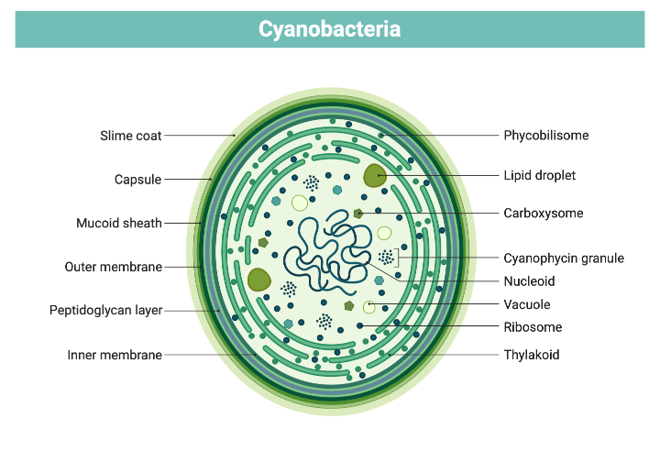
Cyanobacteria, also called blue-green algae, are microscopic organisms found naturally in all types of water. These single-celled organisms live in fresh, brackish (combined salt and fresh water), and marine water. These organisms use sunlight to make their own food. In warm, nutrient-rich (high in phosphorus and nitrogen) environments, cyanobacteria can multiply quickly, creating blooms that spread across the water’s surface. The blooms might become visible.
How are cyanobacteria blooms formed?
Cyanobacteria blooms form when cyanobacteria, which are normally found in the water, start to multiply very quickly. Blooms can form in warm, slow-moving waters that are rich in nutrients from sources such as fertilizer runoff or septic tank overflows. Cyanobacteria blooms need nutrients to survive. The blooms can form at any time, but most often form in late summer or early fall.
What does a cyanobacteria bloom look like?
You might or might not be able to see cyanobacteria blooms. They sometimes stay below the water’s surface, they sometimes float to the surface. Some cyanobacteria blooms can look like foam, scum, or mats, particularly when the wind blows them toward a shoreline. The blooms can be blue, bright green, brown, or red. Blooms sometimes look like paint floating on the water’s surface. As cyanobacteria in a bloom die, the water may smell bad, similar to rotting plants.
Why are some cyanobacteria blooms harmful?
Cyanobacteria blooms that harm people, animals, or the environment are called cyanobacteria harmful algal blooms. Harmful cyanobacteria blooms may affect people, animals, or the environment by: y blocking the sunlight that other organisms need to live. Cyanobacteria blooms can steal the oxygen and nutrients other organisms need to live. y making toxins, called cyanotoxins. Cyanotoxins are among the most powerful natural poisons known. They can make people, their pets, and other animals sick. Unfortunately, there are no remedies to counteract the effects. y You cannot tell if a bloom has toxins by looking at it

Actinobacteria
This microbe can be found in a wide range of aquatic conditions. They are decomposers of organic matter and tend to favor conditions with low concentrations of organic carbon because they can be outcompeted when carbon concentration rise.
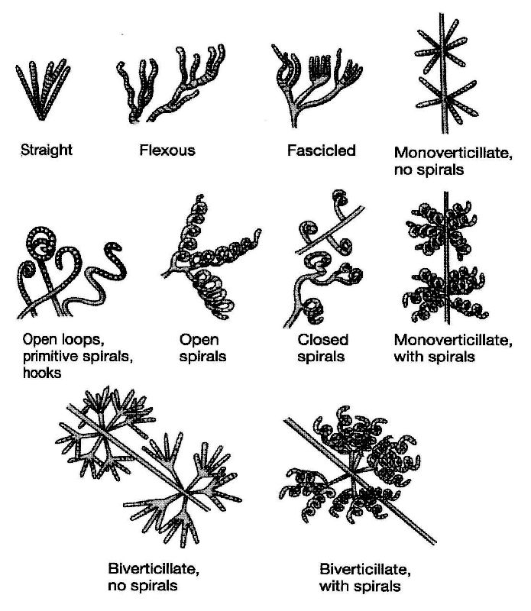
Actinobacteria also cause a range of other diseases in humans, including diphtheria (Corynebacterium diphtheria), Whipple's disease (Tropheryma whipplei), and bacterial vaginosis (Gardnerella)

Bacteroidetes
This microbe is a commonly particle associated in bacterial communities. They are found at the bottom of lakes where they can degrade larger molecules.
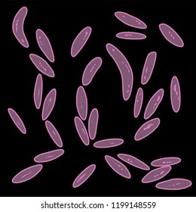
The phylum Bacteroidota (synonym Bacteroidetes) is composed of three large classes of Gram-negative, nonsporeforming, anaerobic or aerobic, and rod-shaped bacteria that are widely distributed in the environment, including in soil, sediments, and sea water, as well as in the guts and on the skin of animals.
0-+
0

