How to Clear Green Pond Water
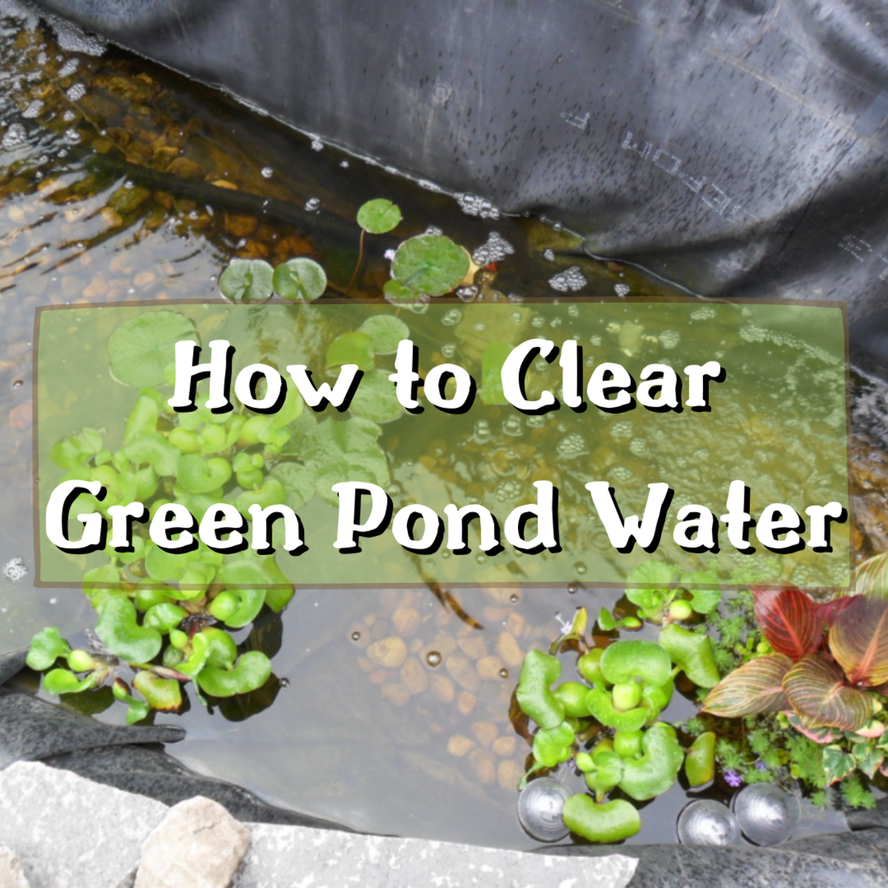
This article teaches you how to efficiently clean and clear up green pond water.

What Causes Green Pond Water?
Green pond water is caused by an abundance of single-cell creatures known as algae. When their numbers reach epidemic proportions, pond water will become like pea soup. Although harmless to fish, the water looks unpleasant and completely ruins the enjoyment of keeping fish and aquatic plants.
The other week we had family visiting from Holland. The Dutch know a great deal about water and water quality. To be honest, my green pond water was an embarrassment to me. I committed to getting my green pond water clear.
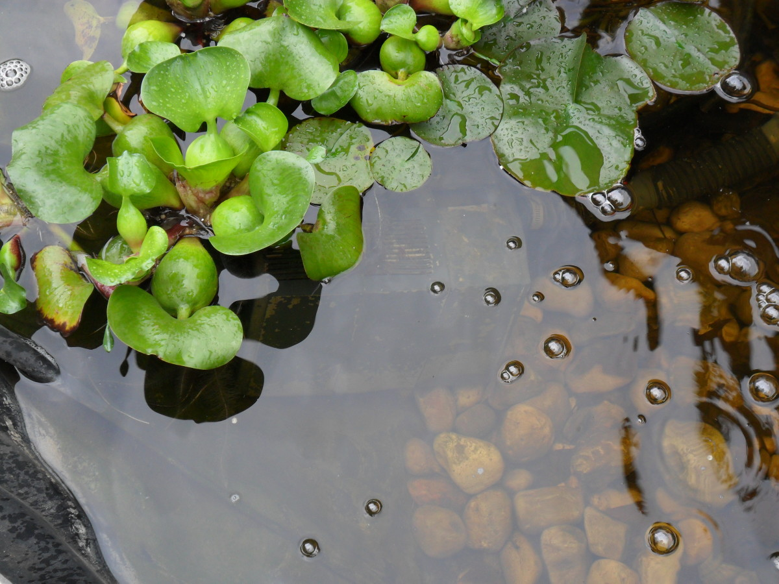
I tried adding various water plants and oxygen to the water, but it did not help. I had to build an effective bio-filter system.

My Experiences With Green Pond Water
Over the last 40 years or so, I've had several small garden ponds, and green pond water has been an ever-present problem. Sometimes I have managed to get the water clear, sometimes not.
Getting the water clear and keeping it that way was somewhat hit or miss.
However, since the advent of the internet and particular sites such as Wikipedia and YouTube, the amount of information and knowledge available to the amateur pond builder and fish keeper has grown exponentially.
The breakthrough came when I fully understood what green water is and how it can be stopped.
The algae that cause green water cannot be filtered out. It is a micro-organism.
Therefore, it must be starved out.

Efforts to Clear My Current Pond
In an effort to clear my current pond, I did several things:
- First, I cleaned out the pre-filter unit attached to the pump and added some "bio-filter" media. Bio-filter is material designed and manufactured to promote the growth of naturally occurring "good" bacteria.
- Secondly, I added an air supply into the pond water with an air pump and air stones.
- Thirdly, I added various water plants.
The pond water remained "pea green," much like pea soup. All this effort for no reward was very frustrating.
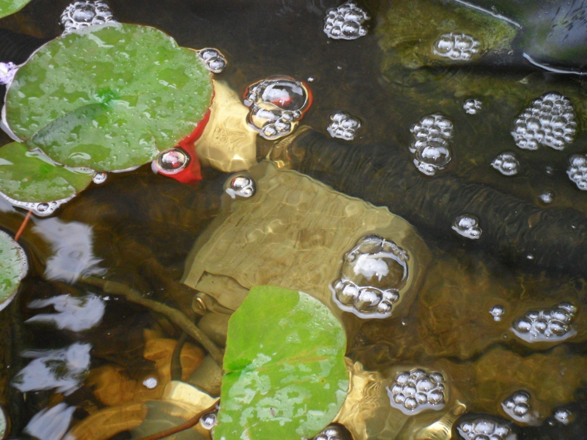
Here, you can see the water pump and the ball valve I used to balance the water flow. By putting all hose connections under water, any small leaks were of no consequence.

Nutrients, Algae and "Good" Bacteria
Creating and maintaining clear pond water stems from having a lack of nutrients for the algae to feed on and an abundance of nutrients for pond plants to eat.
Scroll to Continue

Read More From Dengarden
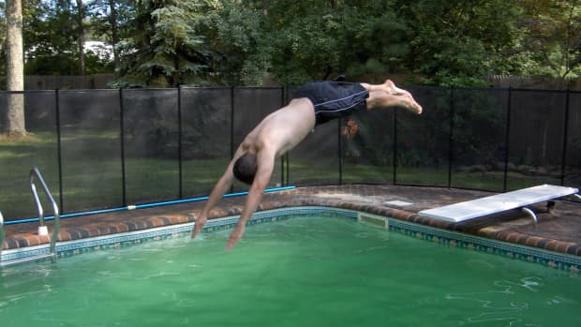

Green to Clean: How to Clear Up a Green and Cloudy Swimming Pool

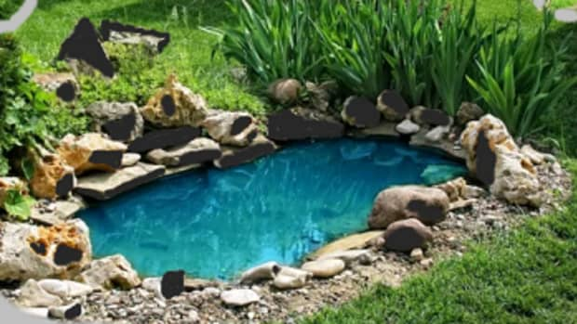

How to Keep Your Pond Clean and Free of Leaves, Mud, and Other Waste

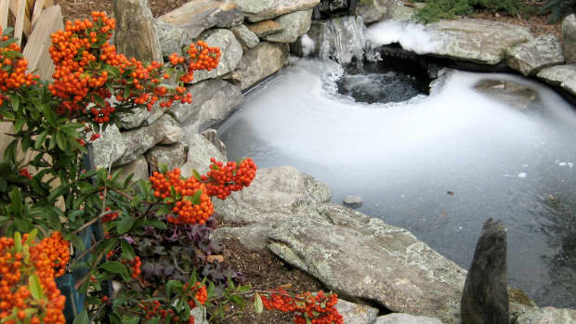

How to Maintain and Care for a Pond

The primary sources of nutrients in a small pond will come from fish waste (their excrement) and uneaten fish food decaying.
There will be two naturally occurring creatures eating these nutrients, algae and "good" bacteria.
Green water means that the algae are more successful at colonising the pond water. In contrast, clear water indicates that the "good" bacteria have the upper hand.
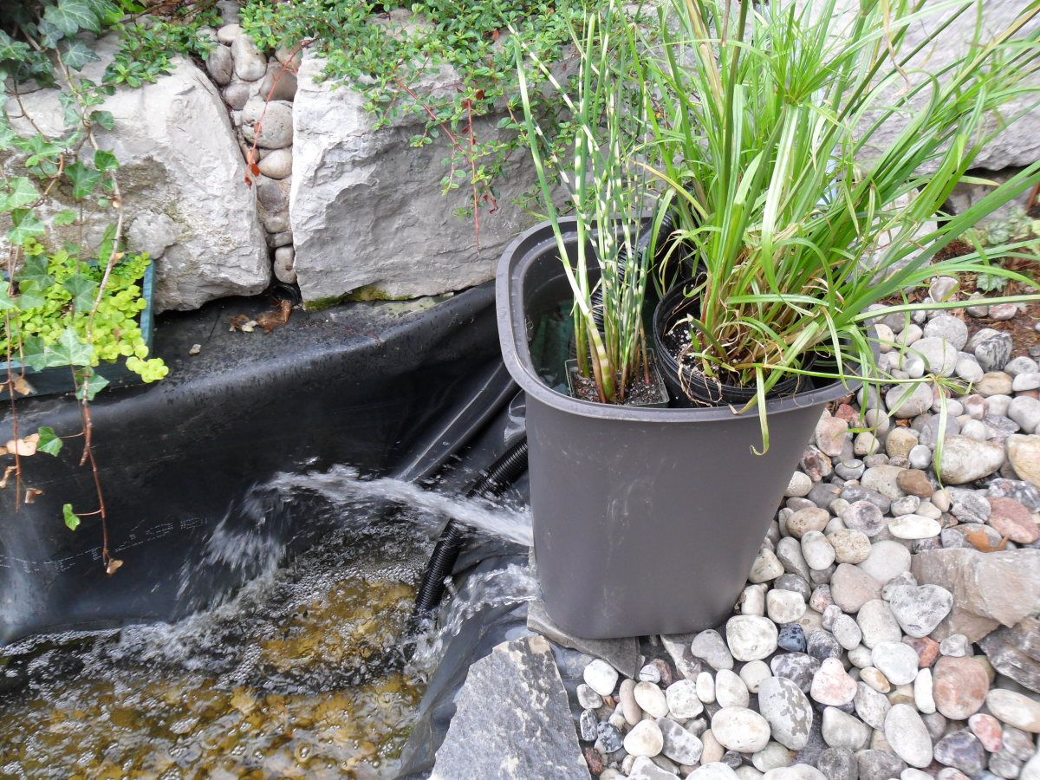
The right-hand container is about 13 gallons and has about 200 scrubber pads inside. I added bio-filter media from my aquarium to get the bacteria colony started. Plants on the top help with the water quality and provide some decoration.

Biological Engineering
After finding out the facts about green pond water, I decided to try my hand at some "biological engineering." That is, I wanted to see if I could create an environment that would enable "good" bacteria to proliferate in my pond water, so I set about designing and building biological filters for my pond.
I already had an air supply, a water pump, and a pre-filter unit, but what else would I need?
After reading articles and watching "how-to" videos, I made a list of materials required to complete my bio-filter project:
- 50' Plastic pipe with joints and hose clips.
- A ball valve.
- Plastic containers (around 5 to 10 gallons each).
- Filter media (scrubber pads from the dollar store).
- A source (an existing colony) of "good" bacteria.
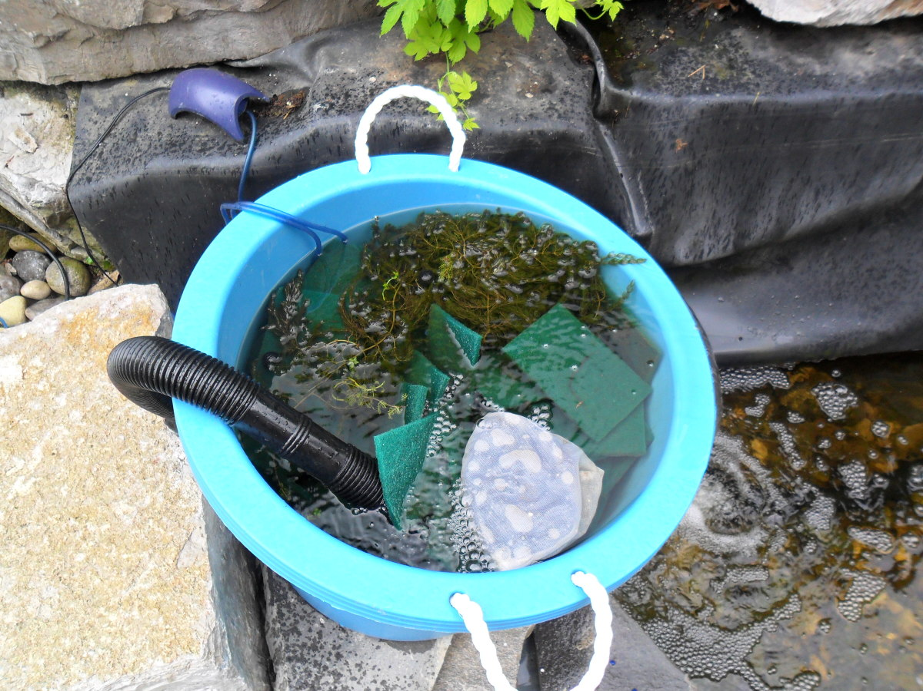
The left-hand container is about 8 gallons and has about 150 scrubber pads inside. The water flows in through the hose and spills over the top. There are bio media in the bag. An air stone at the bottom and weed floating at the top add extra oxygen.

The Basic Concept
The basic concept behind my plan was to create two colonies of "good" bacteria living within plastic containers external to the main body of pond water. The scrubber pads would provide the right kind of "home" for the bacteria to colonise.
The pump, tubing and joints would enable me to create a flow of water between the plastic containers and the pond.

Construction Begins With Dismal Failure
My first attempts at setting up the plastic containers with water flow to and from the pond were a dismal failure. At one point, I thought I might have to abandon the project altogether.
I couldn't get any of the joints in the pipework to seal properly. Water wasn't just leaking here and there; it was spewing from every connection. The joints to and from the plastic containers were so ineffective that I don't want to discuss them any further.
At the end of that first day, I sat in the back yard looking at all the materials scattered across the floor and said to myself, "what a complete waste of my time and hard-earned money!"
I went to sleep that night hoping I'd have some "creative-genius" breakthrough in my thinking.
By the following day, I had some ideas to work with.
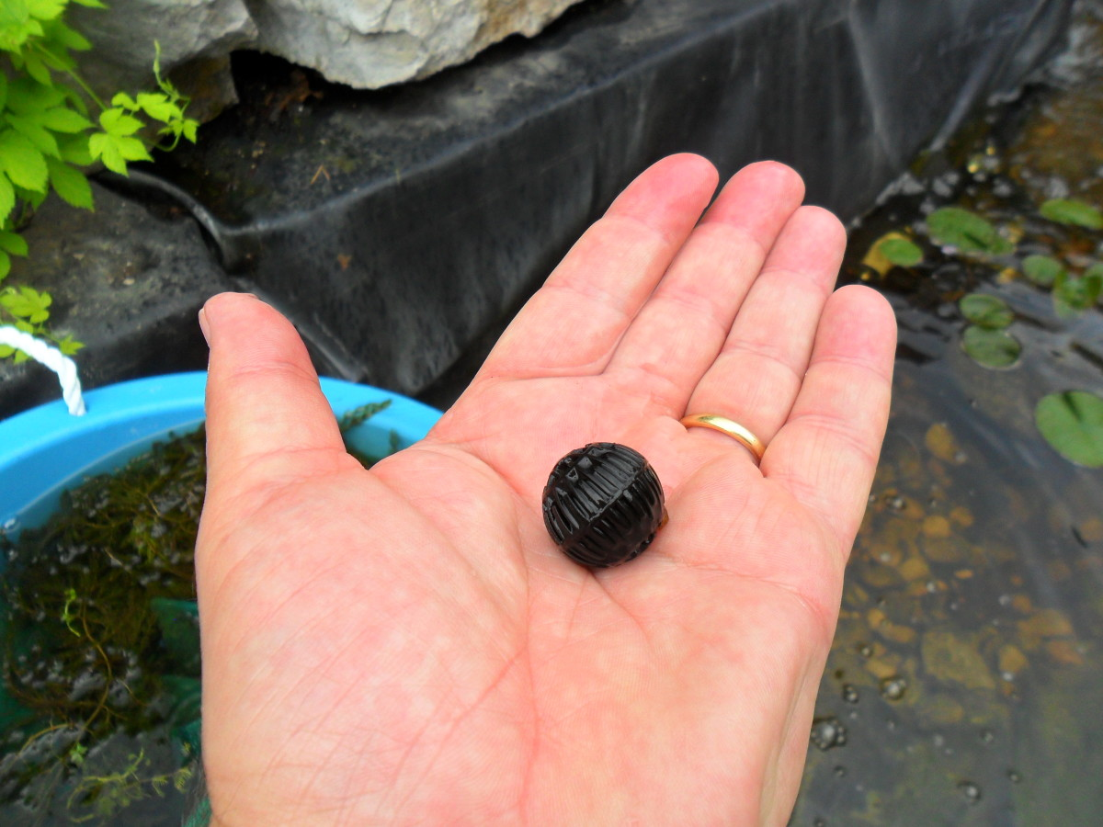
I keep my goldfish in an aquarium over the winter. The filter media, like this bio ball, gave me a source of "good" bacteria to grow my pond colonies quickly.

The Second Day of Construction
During the second day of construction, my hopes were raised that I might get something that worked, even if it didn't look pretty. My plans were based on a single 30-gallon plastic tote.
Trying to get water flowing from the bottom to the top of the container had been causing many problems with leaks at the joints. I could do away with the connections to and from the container by reversing the water flow. Pipe from the pump in at the top, holes in the side of the container at the bottom would allow the water to just pour back into the pond.
I filled the container with scrubber pads to provide an environment for the "good" bacteria to live in.
I had some existing "bio-media" from the pre-filter, so I put that in the middle of the scrubber pads and set the water flowing.
That night I went to bed wondering if the morning would bring success or failure. By the morning, I knew that the water's colour and clarity would soon let me know if I were on the right track or not.

Pond Filter

The Third Day Brings a Breakthrough!
The morning of the third day of construction brought great excitement to our house. The pond water that had been pea green was now clearing. We could see about 3" (75mm) down into the pond. To get the water this clear in just 12 hours was nothing short of miraculous. Also, during the night, I had come up with a way to create water flow to and from two containers without water leaking all over the backyard.
I would put all pipe joints within the confines of the pond.
Here is the sequence of construction I used:
- Pre-filter unit
- Pump
- "Tee" joint
- Hose to right-hand side container
- Hose to left-hand side container with ball valve (to balance water flow)

Filter Material
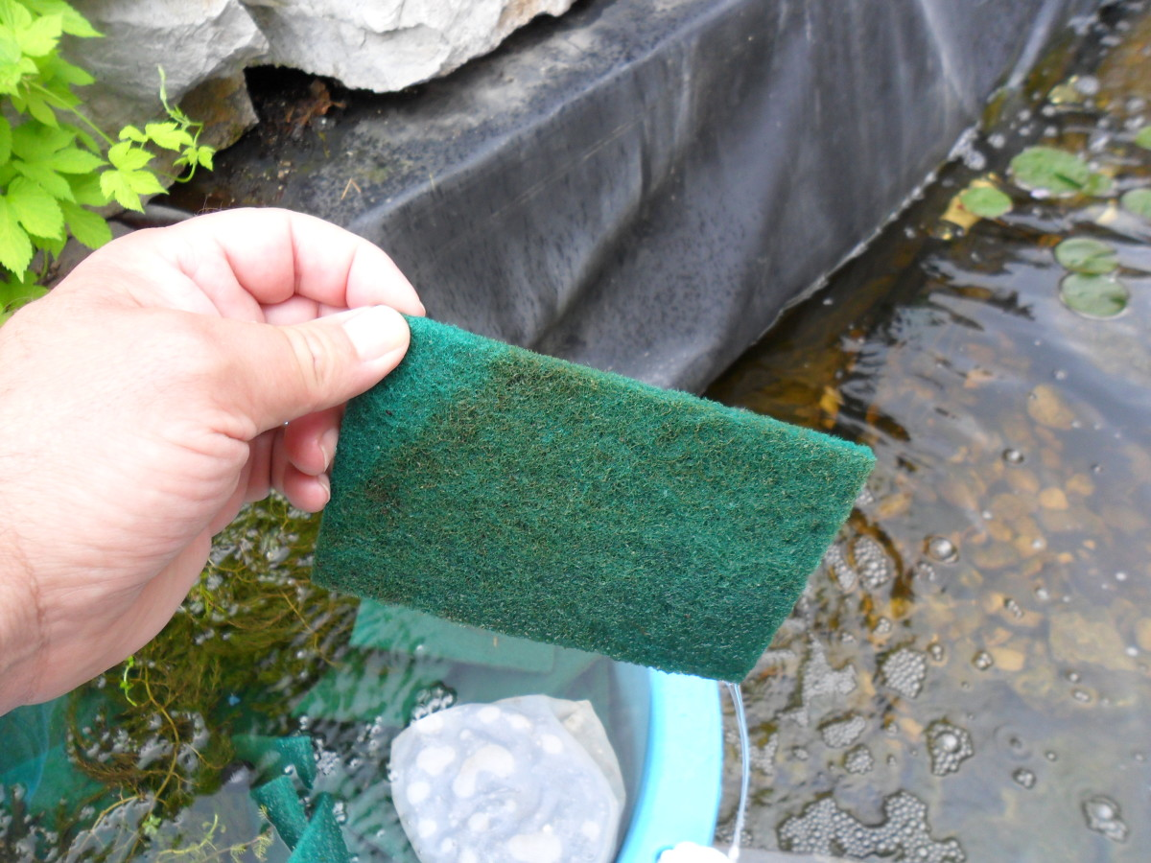
I got the scrubber pads from the local dollar store. About 400 of them for $55. These pads make an ideal home for "good" bacteria colonies.

Clear Water After Just Four Days
By the afternoon of the third day, construction was complete. Any leaks in the joints didn't matter as they were all under water in the pond.
The ball valve was regulating the water flow correctly between the two containers.
When we got up the morning of the fourth day, we had clear pond water. The bottom of the pond was clearly visible.
The two colonies of "good" bacteria living in the scrubber pads had starved the algae to death.
This is how I cleared my green pond water.
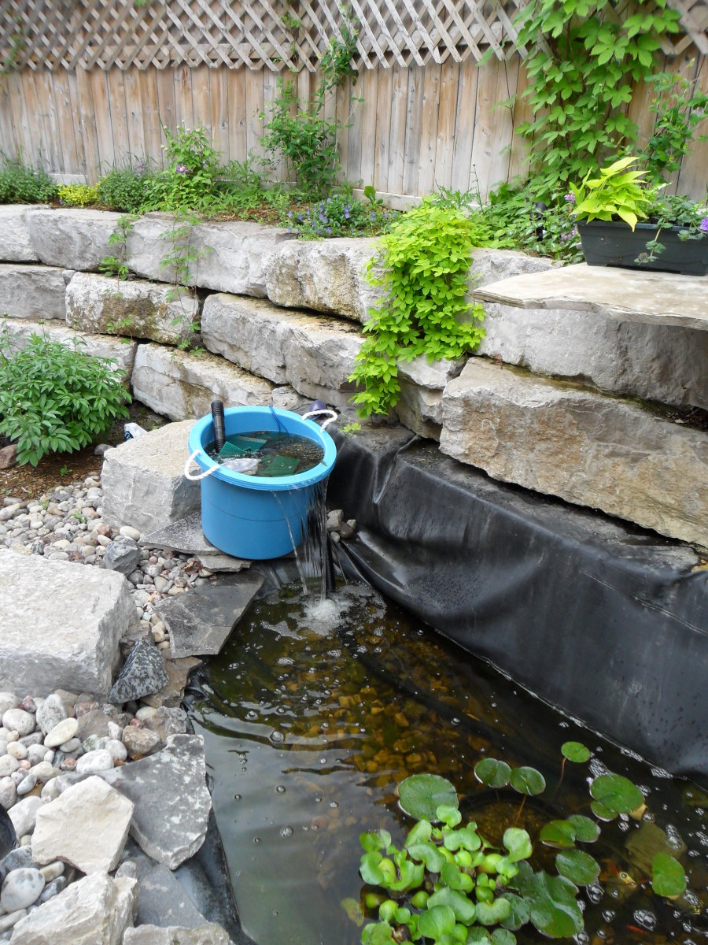
My pond water is now clear. My friends think I'm a biological engineer!

