Organic Waste Recycling (Methods, Steps, Significance, Barriers)

Table of Contents
- What are organic wastes?
  - 1. Municipal solid wastes
  - 2. Cattle wastes
  - 3. Food wastes
- What is organic waste recycling?
- Methods of organic waste recycling
  - 1. Animal feed
  - 2. Composting
  - 3. Anaerobic digestion
  - 4. Rendering
  - 5. Rapid thermophilic digestion
  - 6. Immobilized enzyme reaction
- Process (General Steps / Mechanism) of organic waste recycling
  - 1. Collection
  - 2. Decontamination
  - 3. Preparation
  - 4. Recycling process
  - 5. Screening and grading
- Significance of organic waste recycling
- Barriers and Challenges of organic waste recycling
- References
- Sources

What are organic wastes?
Organic wastes are materials originating from living sources like plants, animals, and microorganisms that are biodegradable and can be broken down into simpler organic molecules.
- Organic wastes produced in nature by various means can exist either in a solid-state or liquid state.
- Solid organic waste is primarily understood as organic-biodegradable waste, and it contains about 80-85% moisture content.
- The most common sources of organic wastes include agriculture, household activities, and industrial products.
- Green waste like food wastes, food-soiled paper, non-hazardous wood waste, landscape waste, and pruning wastes are some of the examples of biodegradable or organic wastes.
- Even though most of the organic wastes in the soil add up nutrients and minerals for soil fertility and plant growth, inappropriate disposal practices might cause severe damage to the environment.
- Recently, however, the concept of organic waste management and recycling has been introduced and implemented.
Organic wastes have been an important source of pollution in the environment. Some of the common types of organic wastes usually found in nature include the following;

1. Municipal solid wastes
- Municipal solid wastes include the more common wastes that are generated in our daily life in the form of product packaging, grass clippings, furniture, clothing, bottles, food scraps, appliances, paint, newspapers, and batteries.
- These wastes are generated from residential areas, schools, hospitals, and businesses.

2. Cattle wastes
- Cattle wastes are animal wastes that are of animal origin and act as good resources of organic matter.
- Cattle waste is also an important soil fertilizer that provides a high concentration of micro and macronutrients for crop growth and soil fertility.
- Cattle manure and fodder constitute organic wastes in the form of cattle wastes. Besides, poultry wastes and piggery wastes also add the number of organic wastes from animal origin.

3. Food wastes
- Food wastes account for about 30% of total organic waste in nature via natural and artificial means.
- Some of the examples of food wastes include peelings, cores, leaves, fruits, twigs, outer skins, and sludges.
- Fruit and vegetable canning industries, frozen vegetable industries, and fruit drying industries, along with residential areas and hotels or restaurants are the major producers of food wastes.
1.5M
240
Marine Biologists Capture Video of One of Earth’s Rarest Known Aquatic Species

What is organic waste recycling?
Organic waste recycling is the process of organic waste management where organic wastes are recycled or converted into useful matter by different recycling methods.
- The need for organic waste recycling has increased over the years as waste management became an emerging issue in most metropolitan cities.
- Organic waste account for most of the waste created in nature which then directly affects urban living systems due to their high moisture content.
- The excess moisture content increases the volume of waste while lowering their incinerator temperatures, causing an overall load of waste disposal.
- In order to deal with these issues, various treatment methods and practices have been formulated and implemented throughout the world.
- The utilization of microorganisms in organic waste management is also a viable means of improving soil fertility while disposing of such wastes.
- During the process of organic waste recycling, the wastes are subjected to different forms of treatments, resulting in the conversion of waste into compost or vermicompost that can then be utilized as natural fertilizers.
- Biological treatments are among the most convenient and effective alternative for treating organic waste.
- These treatments help maximize recycling and recovery of waste components.
- The primary objective of organic waste recycling is to maintain a sustainable cycle where the biodegradable fraction of organic waste is converted into useful organic manure or fertilizer through various recycling techniques.
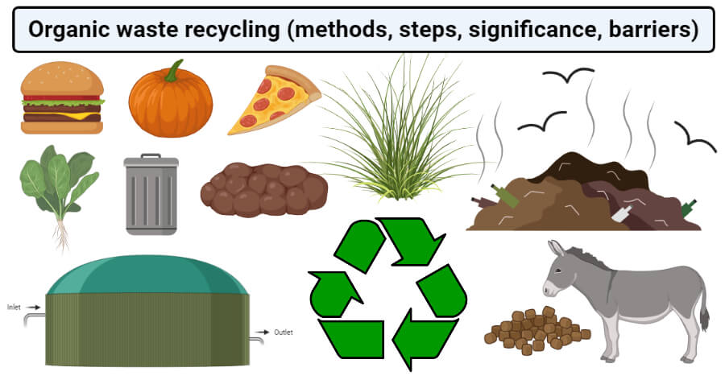Created with BioRender.com

Methods of organic waste recycling
There are different methods of organic waste recycling, each of which can be used for a particular group of waste to produce some form of useful organic matter. Some of the common methods are described below:

1. Animal feed
- One of the most common and efficient ways of recycling organic waste is by giving agricultural and food waste to cattle and other animals as food.
- Feeding organic waste to animals is a simple and easy method of waste recycling.
- People can contact some farmers and donate their kitchen wastes so that the animals can take them up.
- However, the direct feeding of organic waste to animals might result in some health issues in such animals.
- Therefore, different countries like the US have made regulations on the extent of food and type of food given to the animals.
- Recycling of food through animal feed has many advantages like reduced pressure on landfills, reduced methane productions from fruits and vegetables, and the lack of need to convert organic waste into some other forms.
- This also helps the farmers as they do not have to buy extra animal feed and eventually, helps the economy.

2. Composting
- Composting is the process of decomposition of organic material where the organic material is acted on by soil organisms resulting in the recycling of nitrogen, phosphorus, potassium, and other soil nutrients into humus-rich components.
- Composting is an aerobic process that takes place under correct conditions of moisture and biological heat production.
- Even though all organic matter can be composted, some materials like woodchips and paper take much longer to compost than food and agricultural wastes.
- However, some amount of woodchips is essential to increase aeration in the composting process.
- The overall process of composting includes both the composting time followed by a period of stabilization to produce a final stable product that can then be applied to the land.
- There are different composting systems ranging from simple, low-cost bin composting to highly technical high-cost reactor systems.
- Compost bins are most suitable for use in houses to compost simple kitchen waste and garden cuttings. One of the major issues with compost bins is the time taken for the completion of the process.
- Large scale composting is conducted in large reactors with an automated supply of oxygen and moisture to generate large tons of compost for industrial applications.

3. Anaerobic digestion
- Due to the negative impacts of landfilling and incineration, anaerobic digestion has been proposed due to the cost-effective technology for renewable energy production and treatment of high moisture and energy-rich material.
- During the anaerobic digestion process, anaerobic microorganisms convert different types of biomass and other organic wastes into biogas and nutrient-rich residue that can be used for lap applications.
- The biogas produced by anaerobic digestion includes gases like methane, carbon dioxide, and a trace amount of hydrogen and hydrogen sulfide.
- When compared to other methods, this method can utilize a much wider range of substrates, even those with high moisture content and impurities.
- Some of the commonly used substrates for anaerobic digestion include wastewater, sewage sludge, and animal manure.

4. Rendering
- Rendering is the process of conversion of waste animal tissues into stable and usable forms like feed protein.
- During the rendering process, fatty tissues, bones, and animal carcass are exposed to a high temperature of about 130°C and then pressurized to destroy pathogens.
- Rendering can be carried out on both the kitchen and industrial scale.
- Some cases of non-animal products can also be rendered down to form pulps.
- The products of rendering can be applied in different forms where the solid particles are used in pet food products, and the fat is added to soap making operations.
- Rendering, however, has some disadvantages like it cannot completely degrade waste products like blood.

5. Rapid thermophilic digestion
- Rapid thermophilic digestion is the process of rapid fermentation of organic wastes by activating fermenting microorganisms at high temperatures.
- A rapid thermophilic digester works six to ten times faster than a normal biodigester.
- In a thermophilic digester, the feedstock is fed into the digester with air forced through the material to support the growth of aerobic microbes.
- The process of thermophilic digestion is an exothermic process that maintains a thermophilic condition at 55-65°C.
- The product of rapid thermophilic digestion is a biofertilizer that can be used on the soil to increase soil fertility.
- The most common application of thermophilic aerobic digestion is in the wastewater industry for the treatment of sewage sludges.

6. Immobilized enzyme reaction
- The use of enzymes over chemical catalysts in the treatment of wastewater and other similar waste products reduces the formation of by-products and significant energy inputs.
- However, some challenges like maintaining the stability and performance of enzymes require the development of stabilized energy systems.
- The use of immobilized enzymes during organic waste recycling allows the degradation activity even under non-ideal environments.
- Immobilization of enzymes also supports the reuse of biocatalysts for multiple processes which then reduces the cost of chemical and enzymatic processes.
- Immobilization techniques like adsorption, entrapment, and encapsulation can be applied.
- The use of enzymes for the conversion of organic waste into reusable forms allows important modifications like oxidation, hydrolysis, acylation, and phosphorylation.
- Enzymes like esterases can be used to esterify oils to form biodiesel. Similarly, sugars can also be esterified to use as surfactants.
- All of these processes allow for a more economical and efficient way of waste management.

Process (General Steps / Mechanism) of organic waste recycling
The overall process of organic waste recycling begins with the collection of waste materials which are then passed through various steps to obtain a usable form of organic matter. The general steps/ mechanism of organic waste recycling can be explained as below;

1. Collection
- The first step in the organic waste management of recycling is the collection of waste materials which can either be on a small scale in a kitchen or on a large scale in industries.
- A sufficient amount of waste matter needs to be collected in appropriate bags so that they can be moved to the site of recycling.
- In the case of composting, the organic waste is collected in a pit, whereas that in a digester is collected in the digester.

2. Decontamination
- An important step in organic waste recycling is the decontamination of waste in order to avoid its harmful effects.
- This step is particularly important while dealing with organic waste from industries.
- Besides, any non-biodegradable substance like glass, plastic, and bricks, if present, should be removed during this step.

3. Preparation
- Before the organic waste is added to a recycling system, it should be prepared.
- The method of preparation employed depends on the type of recycling method chose. For, e.g., composting requires shredding and stacking of organic waste, whereas an immobilized enzyme system requires immobilized enzymes.
- Some methods might even require a period of stabilization prior to recycling, in which case, the time should be designated.

4. Recycling process
- Depending on the nature of the organic waste and desired end products, an appropriate method of recycling should be adopted.
- Human wastes like sewage and fecal wastes should be recycled via anaerobic digestion whereas sewages can be treated with thermophilic digesters.

5. Screening and grading
- The obtained residues or compost are then screened into different sizes to be used for different purposes.
- Depending on the application of the end products, grading and screening are essential.

Significance of organic waste recycling
Organic waste recycling has multiple advantages that help prevent the problems that arise with the accumulation of waste products in nature. Some of the common advantages or significances of organic waste recycling are:
- Recycling of biomass or biowastes allows for the generation of energy in the form of biogas by recycling processes like anaerobic digestion.
- The conversion of organic matter into compost helps save resources as compost can be used as a biofertilizer which avoids the use of other chemical fertilizers.
- The separation of organic and inorganic wastes also improves the efficiency of non-organic recycling.
- One of the most important significances of organic waste recycling is the reduction of pollution in the air, water, and land as it reduces problems like odor generation or gas emissions.
- The generation of biofertilizers by recycling process improves the quality of soil, which then increases soil fertility and plant growth.
- Landfills tend to increase the emission of greenhouse gases, and the recycling of such wastes into less harmful wastes decreases such emissions.
- Recycling of organic wastes also reduces the concentration of waste remaining for less efficient processes like landfill and incineration.
- Organic matter recycling increases the organic content of the soil, which improves soil fertility and provides essential nutrients to plant, increasing crop yield.
- Stabilization of organic wastes adds value in terms of improving nutrient content and availability to be used as fertilizer in agriculture. Also, it introduces new popular concepts like cleaner production, zero-waste policy, sustainability, and bio-based circular economy.
- Some compost prepared with appropriate substrate work as biocontrol agents to prevent and control plant diseases.

Barriers and Challenges of organic waste recycling
Even though organic waste recycling is a novice and important method of waste recycling, there are some challenges that limit the use of recycling methods. Some of the most prominent barriers or challenges of organic waste recycling are:
- Long term application of compost-recycled waste on soil may cause an accumulation of heavy metals, from where they might transfer to different trophic levels of the food chain.
- Some selected groups of persistent organic pollutants like chlorinated dioxins, polycyclic aromatic hydrocarbons, and organochlorine pesticides are accumulated in solids during the treatment process. These compounds might have harmful effects on lower organisms or in some cases, even on humans and wildlife.
- The use of bio-fertilizers produced via processes like composting and vermicomposting results in significant input of toxic metals like cadmium and lead, which might have a direct impact on the health of human beings and animals.
- Recycling process like composting generates odors which might cause air pollution or discomfort.
- Microbial degradation of organic waste might result in the formation of airborne microorganisms or bioaerosols, which may pose potential risks like respiratory disorders on the plant workers and adjacent residents.

