Sewage-fed fish culture

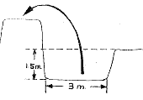
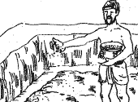
Sewage is a rich nutrient resource, cheaply available around big towns and cities. It can be well-utilized: for fertilizing paddies, fishponds and horticulture crops. Waste recycling also helps in maintaining a clean environment. This paper is based on existing practices in eastern India.

Rice-fish/prawn
In areas where irrigation facilities are not available, a second crop of rice is possible by constructing water storage areas within the field. These could be in the form of lateral, central or marginal trenches or unilateral/bilateral ponds which are also utilized for aquaculture. Based on the input requirements for a 0.4 ha field, the following methods are used by farmers:
1. Raise the peripheral dikes by digging a perimeter trench (3 m wide x 1.5 m deep) or a lateral pond. If necessary, inlets and outlets are provided and guarded with meshed screens.
2. Fill the trench with sewage water to a level of 15-20 cm.
3. Deepwater rice (e.g. CN 570, 652; NC 487 or 492) is sown directly after the first monsoon shower.
4. When the water level in the trench is about 60-70 cm, stock about 400 mature (1.5-2 g) mola (Amblypharyngodon mola), a small indigenous species high in vitamin A) together with 8 000 bata (Labeo bata) having an average weight of 2 g. As soon as 3-4 g prawn (Macrobrachium rosenbergii) are available, 2 000 juveniles are also stocked. The fish and prawn move about the field when the water level in the trench rises and covers the paddy.
Rice-fish/prawn
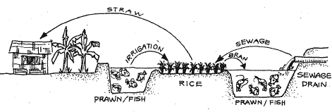
5. The water level in the field and the trench falls with the end of the monsoon. The paddy ripens in November/December and about 500-600 kg of deepwater rice are harvested from the field after 150 days of growing. The fish and prawn continue to grow in the trench. Utilize the water in the trench for raising a second crop of rice. Fertilize it by taking in sewage to a level of about 10 cm each month from December to February. A low-level dike is constructed all around to maintain a 10-15 cm water level in the paddy field.
6. The field is fertilized with sewage and seedlings of high-yielding rice varieties (e.g. Ratna or IET 4094) transplanted in January.
7. Sewage fertilization is repeated when the seedlings have taken roots and again during the flowering stage. The fields are irrigated regularly and the water level is maintained until the rice is mature. Pesticides are used only when necessary.
8. A partial harvest of prawn (50 g), bata (20 g) and mola (20 g) is made.
9. The paddy is harvested in April with a yield of about 2.0-2.4 t.
10. The fish are finally harvested in end April or early May. The total fish harvest is about 112 kg bata, 50 kg prawn and 45-50 kg mola.
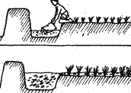 | 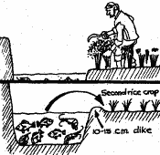 | 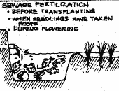
Advantages
1. The second rice crop contributes to additional food production, employment and income generation.
2. Fish crop provides a rich protein food of high market value and adds considerably to the farmer's income.
Sewage system
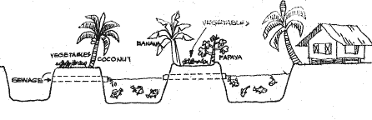
Limitations
1. Trench/pond construction is useful only in water-retentive soils.
2. Difficulties are encountered in fish seed transport, if away from the main road.
Budget (in rupee) for rice-fish-prawn culture in a 0.4 ha unit
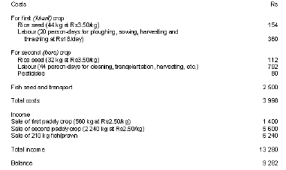
1996: US$1 = Rs25.50

Horticulture-fish
The use of sewage for aquaculture and horticulture results in high yields and economizes on fertilizer and feed costs, resulting in higher profits. Based on the input requirements for a 0.4 ha pond, the following procedure is recommended:
1. Broadcast about 200 kg of quicklime over the entire pond surface after it is drained and dried for about 10-15 days.
2. Load the pond with a 30 cm layer of sewage in early June which gets diluted with rainwater and filled up to a level of 1.2-1.3 m in early July.
3. Stock with 3 000 fingerlings of six species (catla, 15; silver carp, 25; rohu, 25; grass carp, 5; migal, 20; and common carp, 10) or 2 000 fingerlings of three species (catla, 40; rohu, 30; and mrigal, 30).
4. Use the dikes (500-1 000 m² of land around the pond bank) for growing vegetables, beginning with monsoon crops, followed by winter and then summer crops. Each crop is harvested as soon as it is ready. About 1 500 kg of vegetables are harvested from 500 m² of dikes. A wide range of vegetables can be planted in simple mixed or multiple cropping: okra, eggplant, cucurbit, gourds, cabbage, cauliflowers, potato, radish, tomato, onion and leafy vegetables like Amaranthus, Ipomoea, fenugreek, spinach, etc.
5. Load the pond with sewage effluents once a month to the extent of one-fourth or one-fifth of the water level.
Feed all waste leaves to the grass carp in the pond; 80 kg of leaves give about 1 kg of fish.
6. The pond is netted every 15 days and marketable fish is harvested. A total of 2 400 kg of fish can be harvested from the pond.
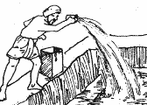 | 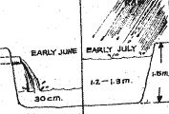 | 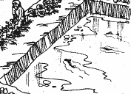 | 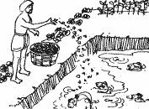
Advantages
1. Waste utilization/recycling of domestic sewage brings about a reduction in biochemical oxygen demand/bacterial load before releasing in streams.
2. High-stocking densities and high-yield rates, especially of plankton feeders as well as detritus feeders, are possible.
3. Low-cost fish/vegetable production.
Disadvantages
1. Copepod parasites due to high organic load cause fish mortalities
2. Sudden fall in oxygen level due to cloudy weather or heavy sewage loading also results in mortalities.
Budget (in rupee) for vegetable production on a 1 000 m² plot on the pond banks
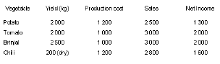
Note: About 25 different kinds of vegetables are grown in single/mixed or multiple cropping and an average production of 3 000 kg valued at Rs7 260 is obtained. With the cost of production being Rs5 400, a net profit of Rs1 860 is taken by farmers. In small farms, the farmer uses own labour which accounts for 60 percent of the total production costs; hence, he nets out an income of Rs1 860 + Rs3 240 = Rs5 100 or US$ 204.00 (as of 1992).

