Transportation of Seed
- In order to ensure the good survival rate after releasing in the pond, it is necessary to communicate to hatchery authorities. So that, it is able to modify the water parameter at the nursery stage itself. i.e., starving one day early to avoid excreting the faecal matter. This is called as "Conditioning of fish".
- Reduce the temperature to minimize the metabolic rate and oxygen consumption.
- Improper transportation may lead to 100% mortality of the seed during travelling as well as after release of the seed into the pond.
- There are many methods of transportation viz. open transportation (in hundy – Traditional Method), closed transportation in plastic bags.
Problems Faced During Transportation:
- Dissolve oxygen level in transporting water reduces and Carbon dioxide level increases.
- Due to metabolic activity of fishes the concentration of ammonia, urea and uric acid etc increase in the water, hence fish gets stress.
- If transportation is done in high density it may lead to mortality of fish due stress of oxygen.
- If transportation is done in improper vessels, physical damage of fishes may occur.
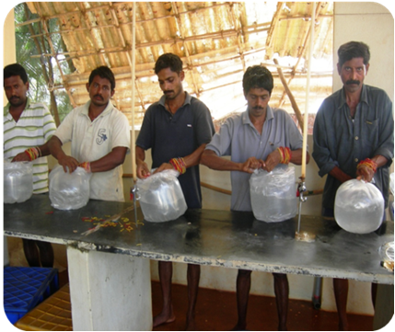
Seed packing

Some Important Tips for Transportation of Fish
- Transportation early in the morning is better (Cool Hour).
- The water used in transportation should be cool and clean.
- Number of fish seeds per transportation unit should be maintained, over number may lead to death of fishes.
- The number of fish seeds to be packed in a bag can be calculated using the below mentioned formula.
N = (DO – 2) x V Where N = Number of fish seeds
C x h DO = Dissolved oxygen
V = Volume of water in 1 liter
C = Rate of oxygen consumption by
individual in mg / kg / hour
h = Period of transportation in hour
- Oxygen packing is the best method of transportation.
- Anaesthetics can be used while transportation to minimize the metabolic activities of the fish seeds. Thereby, excretion of the nitrogenous compounds can be avoided.
- Care should be taken so that no direct sunlight falls in the packing bags during transportation.
- The seed packing bags should be covered with the wet gunny bags. So that, temperature of the seed packing bags will be maintained low.
- If the transporting distance is long, glucose powder can be added to the seed packing bags.
- To remove the toxic ammonia from the media to safeguard the seedlings from the mortality, the absorbent is added which can reduce 50 % of ammonia for 24 hours transportation.
Synthetic amberline resin.
Pulverized earth.
Permutile.
Sodium Phosphate – 2g/l is used as buffer.
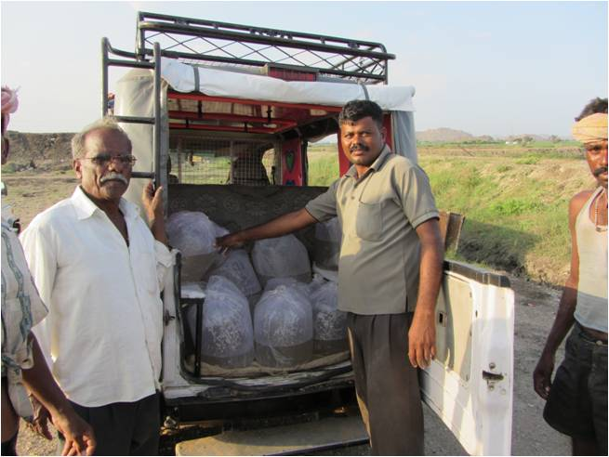
Seed Transportation Vehicle
Number of Fish Seeds To Be Packed While Transportation
Transportation of Seeds
 | 25ºC |  |  | 30ºC
 | 6 hrs | 12 hrs | 24 hrs | 6 hrs | 12 hrs | 24 hrs
Spawn (8mm) | 12000 | 6000 | 3000 | 10000 | 5000 | 2500
Fry (8-40 mm) | 600 | 350 | 175 | 500 | 300 | 150
Fingerlings (40-80 mm) | 175 | 100 | 50 | 150 | 80 | 40

