Structure and Function of Nucleic Acids
Molecular taxonomy uses molecular data, such as DNA and RNA sequences, to identify, classify, and determine the evolutionary relationships among organisms. It is a powerful supplement to traditional morphology, especially when dealing with cryptic species (organisms that look identical but are genetically distinct).
1. Structure and Function of Nucleic Acids
Nucleic acids are the “blueprints” used in molecular taxonomy.
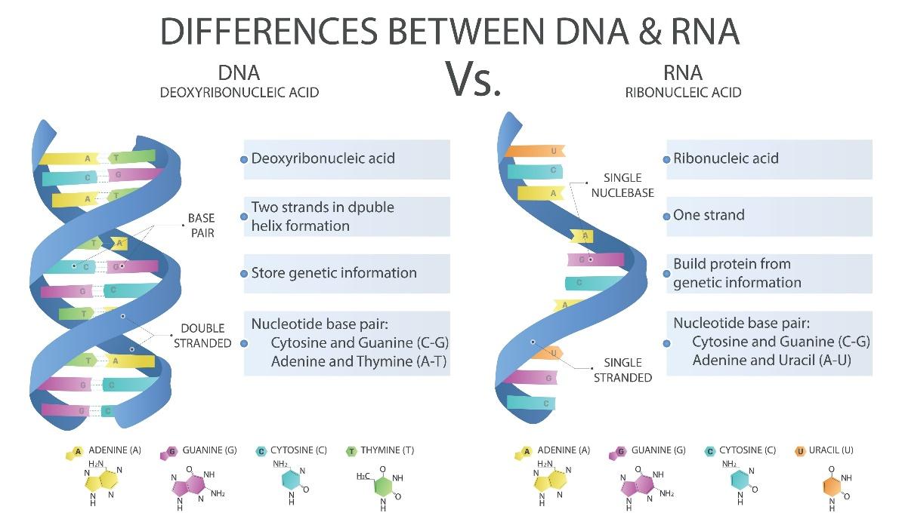
DNA (Deoxyribonucleic Acid)
- A double-stranded helix made of nucleotides (Sugar + Phosphate + Nitrogenous Base: A, T, C, G).
- The sequence of bases provides the primary data for comparing species.
- Role: Long-term storage of genetic information.
RNA (Ribonucleic Acid)
- Usually single-stranded (Bases: A, U, C, G).
- Ribosomal RNA (rRNA) is particularly important in taxonomy because it evolves very slowly, allowing scientists to trace evolutionary relationships over long periods of time.
- Role: Translation of genetic code into proteins.

Nucleic acids are long-chain polymeric molecules. The monomer or repeating unit is known as a nucleotide; hence, nucleic acids are also referred to as polynucleotides. Nucleic acids are organic molecules present in living cells and play a key role in transferring genetic information from one generation to the next. They are composed of DNA (deoxyribonucleic acid) and RNA (ribonucleic acid), which form polymers of nucleotides.
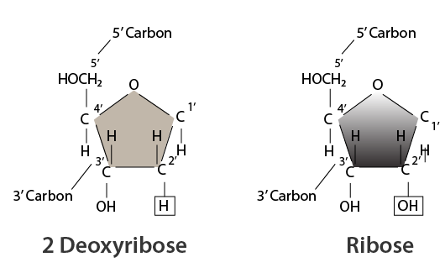
In the nucleus, nucleotide monomers are linked together and comprise distinct components, namely a phosphate group, a pentose sugar (ribose or deoxyribose), and nitrogenous bases. There are two types of nitrogenous bases: pyrimidines and purines. Pyrimidines include cytosine and thymine, while purines include guanine and adenine. In RNA, thymine is replaced by uracil, whereas DNA contains all four bases.
DNA Structure
DNA consists of instructions that control the performance of all cellular functions. It is organized into chromosomes and is present in the nucleus of cells, where it governs cellular activities.
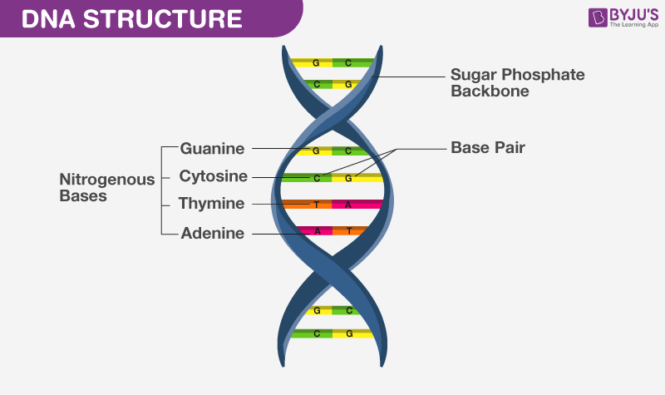
DNA is a double helix formed by two twisted polynucleotide chains. The two strands run parallel to each other and are held together by hydrogen bonds between complementary bases. The bases are located inside the helix, while the sugar-phosphate backbone lies on the outside. Due to the presence of phosphate groups, DNA is negatively charged.
Chemically, DNA is composed of a pentose sugar, phosphoric acid, and cyclic nitrogenous bases. The sugar present in DNA is β-D-2-deoxyribose. The nitrogenous bases are adenine (A), guanine (G), cytosine (C), and thymine (T). The sequence and arrangement of these bases play a crucial role in storing genetic information and transferring it from one generation to the next.
RNA Structure
RNA plays a vital role in protein synthesis, which involves decoding and translation of the genetic code and transcription to produce proteins.
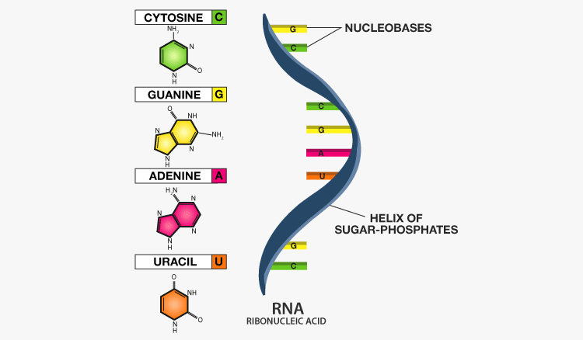
RNA molecules are composed of phosphoric acid, a pentose sugar, and nitrogenous bases. The sugar present in RNA is β-D-ribose. The heterocyclic bases found in RNA are adenine (A), guanine (G), cytosine (C), and uracil (U). Unlike DNA, RNA generally consists of a single strand, which may fold back on itself.
Types of RNA
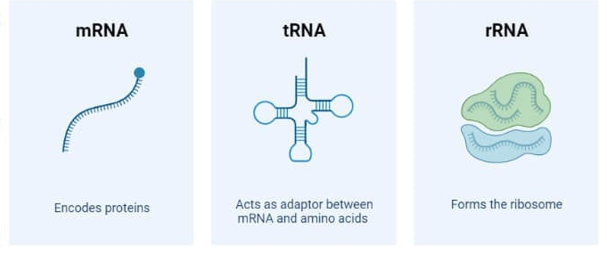
- Ribosomal RNA (rRNA): A structural and functional component of ribosomes involved in protein synthesis.
- Transfer RNA (tRNA): Essential for the translation of mRNA during protein synthesis.
- Messenger RNA (mRNA): The RNA transcript produced during DNA transcription.
- Micro RNA (miRNA): Small RNA molecules that help regulate gene expression.
Functions of Nucleic Acids
- Nucleic acids are responsible for protein synthesis in the body.
- RNA is a vital component of the protein synthesis machinery.
- Loss or alteration of DNA content is linked to many diseases.
- DNA is essential for transferring genes from parents to offspring.
- All cellular information is stored in DNA.
- DNA fingerprinting is used in forensic science to determine paternity and identify criminals. It has also played a major role in studies of biological evolution and genetics.

